OBJECT ORIENTED ANALYSIS & DESIGN

UNIT-I

INTRODUCTION TO UML

Contents:

  - Importance of Modeling

  - Principles of Modeling

  - Object Oriented Modeling

  - Conceptual Model of the UML

  - Architecture

  - Software Development Life Cycle

- Importance of Modeling:

Why do we model?
A model is a simplification at some level of abstraction

We build models to better understand the systems we are developing.
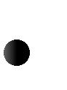
To help us visualize
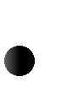
To specify structure or behavior
To provide template for building system
To document decisions we have made

2. Principles of Modeling:
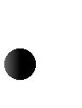
The models we choose have a profound influence on the solution we provide Every model may be expressed at different levels of abstraction
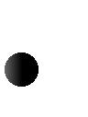
The best models are connected to reality
No single model is sufficient, a set of models is needed to solve any nontrivial system

3. Object Oriented Modeling:

Traditionally two approaches to modeling a software system

Algorithmically – becomes hard to focus on as the requirements change

Object-oriented – models more closely real world entities
4. Conceptual Model of the UML:

Conceptual Model of UML
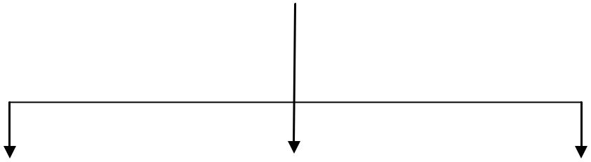

Building Blocks Rules Common Mechanisms
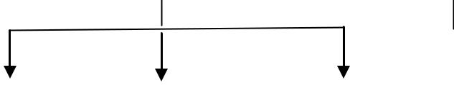
Things Relationships |  |  |  |  |  | Diagrams |  |  | 1) Specifications
 |  |  |  |  |  |  |  | 2) Adornments
 |  |  |  |  | 1. Class Diagram. |  |  |  | 3) Common Divisions
 | 1) | Association |  |  | 2. Object Diagram. |  |  |  | 4) Extensibility Mechanisms
 | 2) | Dependency |  |  | 3. Use Case Diagram.
 | 3) | Generalization |  |  | 4. Sequence Diagram. |  |  |  |  | *Stereotypes
 | 4) | Realization |  |  | 5. Collaboration Diagram. |  |  |  |  | *Tagged Values
 |  |  |  |  | 6. | State Chart Diagram. |  |  | 1) Names *Constraints
 |  |  |  |  | 7. | Activity Diagram. |  |  | 2) Scope
 |  |  |  |  | 9. | Deployment Diagram. |  |  | 3) Visibility
 |  |  |  |  |  |  |  |  | 4) Integrity
 |  |  |  |  |  |  |  |  | 5) Execution

Structural Things | Behavioral Things | Grouping Things Annotational Things
*Classes | *Interaction | *Packages | *notes
*Interfaces | *State machines
*Collaborations | *States
*Use Case
*Component
*Node

To understand the UML, you need to form a conceptual model of the language, and this requires learning three major elements: the UML's basic building blocks, the rules that dictate how those building blocks may be put together, and some common mechanisms that apply throughout the UML. Once you have grasped these ideas, you will be able to read UML models and create some basic ones. As you gain more experience in applying the UML, you can build on this conceptual model, using more advanced features of the language.

Building Blocks of the UML

The vocabulary of the UML encompasses three kinds of building blocks:

- Things
- Relationships
- Diagrams

Things are the abstractions that are first-class citizens in a model; relationships tie these things together; diagrams group interesting collections of things.

Things in the UML

There are four kinds of things in the UML:

- Structural things
- Behavioral things
- Grouping things
- Annotational things

These things are the basic object-oriented building blocks of the UML. You use them to write well-formed models.

Structural Things

Structural things are the nouns of UML models. These are the mostly static parts of a model, representing elements that are either conceptual or physical. Collectively, the structural things are called classifiers.

A class is a description of a set of objects that share the same attributes, operations, relationships, and semantics. A class implements one or more interfaces. Graphically, a class is rendered as a rectangle, usually including its name, attributes, and operations, as in Figure 2-1.

Figure 2-1. Classes

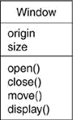

An interface is a collection of operations that specify a service of a class or component. An interface therefore describes the externally visible behavior of that element. An interface might represent the complete behavior of a class or component or only a part of that behavior. An interface defines a set of operation specifications (that is, their signatures) but never a set of operation implementations. The declaration of an interface looks like a class with the keyword «interface» above the name; attributes are not relevant, except sometimes to show constants. An interface rarely stands alone, however. An interface provided by a class to the outside world is shown as a small circle attached to the class box by a line. An interface required by a class from some other class is shown as a small semicircle attached to the class box by a line, as in Figure 2-2.

Figure 2-2. Interfaces
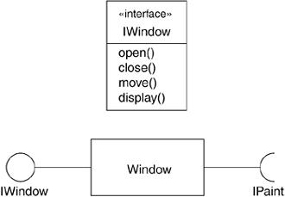

A collaboration defines an interaction and is a society of roles and other elements that work together to provide some cooperative behavior that's bigger than the sum of all the elements. Collaborations have structural, as well as behavioral, dimensions. A given class or object might participate in several collaborations. These collaborations therefore represent the implementation of patterns that make up a system. Graphically, a collaboration is rendered as an ellipse with dashed lines, sometimes including only its name, as in Figure 2-3.
Figure 2-3. Collaborations
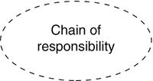

A use case is a description of sequences of actions that a system performs that yield observable results of value to a particular actor. A use case is used to structure the behavioral things in a model. A use case is realized by a collaboration. Graphically, a use case is rendered as an ellipse with solid lines, usually including only its name, as in Figure 2-4.

Figure 2-4. Use Cases
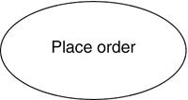

The remaining three things active classes, components, and nodes are all class-like, meaning they also describe sets of entities that share the same attributes, operations, relationships, and semantics. However, these three are different enough and are necessary for modeling certain aspects of an object-oriented system, so they warrant special treatment.

An active class is a class whose objects own one or more processes or threads and therefore can initiate control activity. An active class is just like a class except that its objects represent elements whose behavior is concurrent with other elements. Graphically, an active class is rendered as a class with double lines on the left and right; it usually includes its name, attributes, and operations, as in Figure 2-5.

Figure 2-5. Active Classes
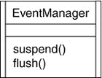

A component is a modular part of the system design that hides its implementation behind a set of external interfaces. Within a system, components sharing the same interfaces can be substituted while preserving the same logical behavior. The implementation of a component can be expressed by wiring together parts and connectors; the parts can include smaller components. Graphically, a component is rendered like a class with a special icon in the upper right corner, as in Figure 2-6.

Figure 2-6. Components
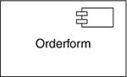

The remaining two elements artifacts and nodes are also different. They represent physical things, whereas the previous five things represent conceptual or logical things.

An artifact is a physical and replaceable part of a system that contains physical information ("bits"). In a system, you'll encounter different kinds of deployment artifacts, such as source code files, executables, and scripts. An artifact typically represents the physical packaging of source or run-time information. Graphically, an artifact is rendered as a rectangle with the keyword «artifact» above the name, as in Figure 2-7.

Figure 2-7. Artifacts
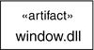

A node is a physical element that exists at run time and represents a computational resource, generally having at least some memory and, often, processing capability. A set of components may reside on a node and may also migrate from node to node. Graphically, a node is rendered as a cube, usually including only its name, as in Figure 2-8.

Figure 2-8. Nodes
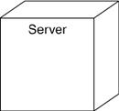

These elements classes, interfaces, collaborations, use cases, active classes, components, artifacts, and nodes are the basic structural things that you may include in a UML model. There are also variations on these, such as actors, signals, and utilities (kinds of classes); processes and threads (kinds of active classes); and applications, documents, files, libraries, pages, and tables (kinds of artifacts).

Behavioral Things

Behavioral things are the dynamic parts of UML models. These are the verbs of a model, representing behavior over time and space. In all, there are three primary kinds of behavioral things.

First, an interaction is a behavior that comprises a set of messages exchanged among a set of objects or roles within a particular context to accomplish a specific purpose. The behavior of a society of objects or of an individual operation may be specified with an interaction. An interaction involves a number of other elements, including messages, actions, and connectors (the connection between objects). Graphically, a message is rendered as a directed line, almost always including the name of its operation, as in Figure 2-9.

Figure 2-9. Messages

Second, a state machine is a behavior that specifies the sequences of states an object or an

interaction goes through during its lifetime in response to events, together with its responses to those events. The behavior of an individual class or a collaboration of classes may be specified with a state machine. A state machine involves a number of other elements, including states, transitions (the flow from state to state), events (things that trigger a transition), and activities (the response to a transition). Graphically, a state is rendered as a rounded rectangle, usually including its name and its substates, if any, as in Figure 2-10.

Figure 2-10. States
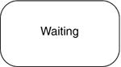

Third, an activity is a behavior that specifies the sequence of steps a computational process performs. In an interaction, the focus is on the set of objects that interact. In a state machine, the focus is on the life cycle of one object at a time. In an activity, the focus is on the flows among steps without regard to which object performs each step. A step of an activity is called an action. Graphically, an action is rendered as a rounded rectangle with a name indicating its purpose. States and actions are distinguished by their different contexts.

Figure 2-11. Actions
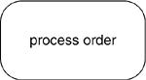

These three elements interactions, state machines, and activities are the basic behavioral things that you may include in a UML model. Semantically, these elements are usually connected to various structural elements, primarily classes, collaborations, and objects.

Grouping Things

Grouping things are the organizational parts of UML models. These are the boxes into which a model can be decomposed. There is one primary kind of grouping thing, namely, packages.

A package is a general-purpose mechanism for organizing the design itself, as opposed to classes, which organize implementation constructs. Structural things, behavioral things, and even other grouping things may be placed in a package. Unlike components (which exist at run time), a package is purely conceptual (meaning that it exists only at development time). Graphically, a package is rendered as a tabbed folder, usually including only its name and, sometimes, its contents, as in Figure 2-12.

Figure 2-12. Packages
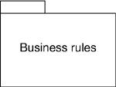

Packages are the basic grouping things with which you may organize a UML model. There are also variations, such as frameworks, models, and subsystems (kinds of packages).

Annotational Things

Annotational things are the explanatory parts of UML models. These are the comments you may apply to describe, illuminate, and remark about any element in a model. There is one primary kind of annotational thing, called a note. A note is simply a symbol for rendering constraints and comments attached to an element or a collection of elements. Graphically, a note is rendered as a rectangle with a dog-eared corner, together with a textual or graphical comment, as in Figure 2-13.

Figure 2-13. Notes
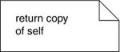

This element is the one basic annotational thing you may include in a UML model. You'll typically use notes to adorn your diagrams with constraints or comments that are best expressed in informal or formal text. There are also variations on this element, such as requirements (which specify some desired behavior from the perspective of outside the model).

Relationships in the UML

There are four kinds of relationships in the UML:

1. Dependency
- Association
- Generalization
- Realization

These relationships are the basic relational building blocks of the UML. You use them to write well-formed models.

First, a dependency is a semantic relationship between two model elements in which a change to one element (the independent one) may affect the semantics of the other element (the dependent one). Graphically, a dependency is rendered as a dashed line, possibly directed, and occasionally including a label, as in Figure 2-14.

Figure 2-14. Dependencies

Second, an association is a structural relationship among classes that describes a set of links, a link being a connection among objects that are instances of the classes. Aggregation is a special kind of association, representing a structural relationship between a whole and its parts. Graphically, an association is rendered as a solid line, possibly directed, occasionally including a label, and often containing other adornments, such as multiplicity and end names, as in Figure 2-15.

Figure 2-15. Associations
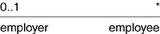

Third, a generalization is a specialization/generalization relationship in which the specialized element (the child) builds on the specification of the generalized element (the parent). The child shares the structure and the behavior of the parent. Graphically, a generalization relationship is rendered as a solid line with a hollow arrowhead pointing to the parent, as in Figure 2-16.

Figure 2-16. Generalizations

Fourth, a realization is a semantic relationship between classifiers, wherein one classifier specifies a contract that another classifier guarantees to carry out. You'll encounter realization relationships in two places: between interfaces and the classes or components that realize them, and between use cases and the collaborations that realize them. Graphically, a realization relationship is rendered as a cross between a generalization and a dependency relationship, as in Figure 2-17.

Figure 2-17. Realizations

These four elements are the basic relational things you may include in a UML model. There are also variations on these four, such as refinement, trace, include, and extend.

Diagrams in the UML

A diagram is the graphical presentation of a set of elements, most often rendered as a connected graph of vertices (things) and paths (relationships). You draw diagrams to visualize a system from different perspectives, so a diagram is a projection into a system. For all but the most trivial systems, a diagram represents an elided view of the elements that make up a system. The same element may appear in all diagrams, only a few diagrams (the most common case), or in no diagrams at all (a very rare case). In theory, a diagram may contain any combination of things and relationships. In practice, however, a small number of common combinations arise, which are consistent with the five most useful views that comprise the architecture of a software-intensive system. For this reason, the UML includes thirteen kinds of diagrams:

- Class diagram
- Object diagram
- Component diagram
- Composite structure diagram
- Use case diagram
- Sequence diagram
- Communication diagram
- State diagram
- Activity diagram
- Deployment diagram
- Package diagram
- Timing diagram
- Interaction overview diagram

A class diagram shows a set of classes, interfaces, and collaborations and their relationships.

These diagrams are the most common diagram found in modeling object-oriented systems. Class diagrams address the static design view of a system. Class diagrams that include active classes address the static process view of a system. Component diagrams are variants of class diagrams.

An object diagram shows a set of objects and their relationships. Object diagrams represent static snapshots of instances of the things found in class diagrams. These diagrams address the static design view or static process view of a system as do class diagrams, but from the perspective of real or prototypical cases.

A component diagram is shows an encapsulated class and its interfaces, ports, and internal structure consisting of nested components and connectors. Component diagrams address the static design implementation view of a system. They are important for building large systems from smaller parts. (UML distinguishes a composite structure diagram, applicable to any class, from a component diagram, but we combine the discussion because the distinction between a component and a structured class is unnecessarily subtle.)

A use case diagram shows a set of use cases and actors (a special kind of class) and their relationships. Use case diagrams address the static use case view of a system. These diagrams are especially important in organizing and modeling the behaviors of a system.

Both sequence diagrams and communication diagrams are kinds of interaction diagrams. An interaction diagram shows an interaction, consisting of a set of objects or roles, including the messages that may be dispatched among them. Interaction diagrams address the dynamic view of a system. A sequence diagram is an interaction diagram that emphasizes the time-ordering of messages; a communication diagram is an interaction diagram that emphasizes the structural organization of the objects or roles that send and receive messages. Sequence diagrams and communication diagrams represent similar basic concepts, but each diagram emphasizes a different view of the concepts. Sequence diagrams emphasize temporal ordering, and communication diagrams emphasize the data structure through which messages flow. A timing diagram (not covered in this book) shows the actual times at which messages are exchanged.

A state diagram shows a state machine, consisting of states, transitions, events, and activities. A state diagrams shows the dynamic view of an object. They are especially important in modeling the behavior of an interface, class, or collaboration and emphasize the event-ordered behavior of an object, which is especially useful in modeling reactive systems

An activity diagram shows the structure of a process or other computation as the flow of control and data from step to step within the computation. Activity diagrams address the dynamic view of a system. They are especially important in modeling the function of a system and emphasize the flow of control among objects.

A deployment diagram shows the configuration of run-time processing nodes and the components that live on them. Deployment diagrams address the static deployment view of an architecture. A node typically hosts one or more artifacts.

An artifact diagram shows the physical constituents of a system on the computer. Artifacts include files, databases, and similar physical collections of bits. Artifacts are often used in conjunction with deployment diagrams. Artifacts also show the classes and components that they implement. (UML treats artifact diagrams as a variety of deployment diagram, but we discuss them separately.)

A package diagram shows the decomposition of the model itself into organization units and their dependencies.

A timing diagram is an interaction diagram that shows actual times across different objects or roles, as opposed to just relative sequences of messages. An interaction overview diagram is a hybrid of an activity diagram and a sequence diagram. These diagrams have specialized uses and so are not discussed in this book. See the UML Reference Manual for more details.

This is not a closed list of diagrams. Tools may use the UML to provide other kinds of diagrams, although these are the most common ones that you will encounter in practice.

Rules of the UML

The UML's building blocks can't simply be thrown together in a random fashion. Like any language, the UML has a number of rules that specify what a well-formed model should look like. A well-formed model is one that is semantically self-consistent and in harmony with all its related models.

The UML has syntactic and semantic rules for

Names What you can call things, relationships, and diagrams

Scope The context that gives specific meaning to a name

Visibility How those names can be seen and used by others

Integrity How things properly and consistently relate to one another

Execution What it means to run or simulate a dynamic model

Models built during the development of a software-intensive system tend to evolve and may be viewed by many stakeholders in different ways and at different times. For this reason, it is common for the development team to not only build models that are well-formed, but also to build models that are

Elided Certain elements are hidden to simplify the view

Incomplete Certain elements may be missing

Inconsistent The integrity of the model is not guaranteed

These less-than-well-formed models are unavoidable as the details of a system unfold and churn during the software development life cycle. The rules of the UML encourage you but do not force you to address the most important analysis, design, and implementation questions that push such models to become well-formed over time.

Common Mechanisms in the UML

A building is made simpler and more harmonious by the conformance to a pattern of common features. A house may be built in the Victorian or French country style largely by using certain architectural patterns that define those styles. The same is true of the UML. It is made simpler by the presence of four common mechanisms that apply consistently throughout the language.

- Specifications
- Adornments
- Common divisions
- Extensibility mechanisms

Specifications

The UML is more than just a graphical language. Rather, behind every part of its graphical notation there is a specification that provides a textual statement of the syntax and semantics of that building block. For example, behind a class icon is a specification that provides the full set of attributes, operations (including their full signatures), and behaviors that the class embodies; visually, that class icon might only show a small part of this specification. Furthermore, there might be another view of that class that presents a completely different set of parts yet is still consistent with the class's underlying specification. You use the UML's graphical notation to

visualize a system; you use the UML's specification to state the system's details. Given this split, it's possible to build up a model incrementally by drawing diagrams and then adding semantics to the model's specifications, or directly by creating a specification, perhaps by reverse engineering an existing system, and then creating diagrams that are projections into those specifications.

The UML's specifications provide a semantic backplane that contains all the parts of all the models of a system, each part related to one another in a consistent fashion. The UML's diagrams are thus simply visual projections into that backplane, each diagram revealing a specific interesting aspect of the system.

Adornments

Most elements in the UML have a unique and direct graphical notation that provides a visual representation of the most important aspects of the element. For example, the notation for a class is intentionally designed to be easy to draw, because classes are the most common element found in modeling object-oriented systems. The class notation also exposes the most important aspects of a class, namely its name, attributes, and operations.

A class's specification may include other details, such as whether it is abstract or the visibility of its attributes and operations. Many of these details can be rendered as graphical or textual adornments to the class's basic rectangular notation. For example, Figure 2-18 shows a class, adorned to indicate that it is an abstract class with two public, one protected, and one private operation.

Figure 2-18. Adornments

Every element in the UML's notation starts with a basic symbol, to which can be added a variety of adornments specific to that symbol.

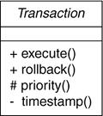

Common Divisions

In modeling object-oriented systems, the world often gets divided in several ways.

First, there is the division of class and object. A class is an abstraction; an object is one concrete

manifestation of that abstraction. In the UML, you can model classes as well as objects, as shown in Figure 2-19. Graphically, the UML distinguishes an object by using the same symbol as its class and then simply underlying the object's name.

Figure 2-19. Classes and Objects
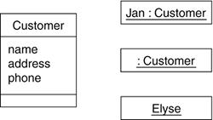

In this figure, there is one class, named Customer, together with three objects: Jan (which is marked explicitly as being a Customer object), :Customer (an anonymous Customer object), and Elyse (which in its specification is marked as being a kind of Customer object, although it's not shown explicitly here).

Almost every building block in the UML has this same kind of class/object dichotomy. For example, you can have use cases and use case executions, components and component instances, nodes and node instances, and so on.

Second, there is the separation of interface and implementation. An interface declares a contract, and an implementation represents one concrete realization of that contract, responsible for faithfully carrying out the interface's complete semantics. In the UML, you can model both interfaces and their implementations, as shown in Figure 2-20.

Figure 2-20. Interfaces and Implementations
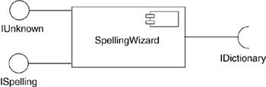
In this figure, there is one component named SpellingWizard.dll that provides (implements) two interfaces, IUnknown and ISpelling. It also requires an interface, IDictionary, that must be provided by another component.

Almost every building block in the UML has this same kind of interface/implementation dichotomy. For example, you can have use cases and the collaborations that realize them, as well as operations and the methods that implement them.

Third, there is the separation of type and role. The type declares the class of an entity, such as an object, an attribute, or a parameter. A role describes the meaning of an entity within its context, such as a class, component, or collaboration. Any entity that forms part of the structure of another entity, such as an attribute, has both characteristics: It derives some of its meaning from its inherent type and some of its meaning from its role within its context (Figure 2-21).

Figure 2-21. Part with role and type
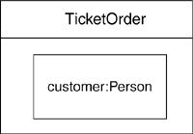

Extensibility Mechanisms

The UML provides a standard language for writing software blueprints, but it is not possible for one closed language to ever be sufficient to express all possible nuances of all models across all domains across all time. For this reason, the UML is opened-ended, making it possible for you to extend the language in controlled ways. The UML's extensibility mechanisms include

Stereotypes
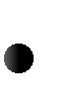
Tagged values
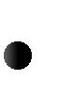
Constraints

A stereotype extends the vocabulary of the UML, allowing you to create new kinds of building blocks that are derived from existing ones but that are specific to your problem. For example, if you are working in a programming language, such as Java or C++, you will often want to model exceptions. In these languages, exceptions are just classes, although they are treated in very special ways. Typically, you only want to allow them to be thrown and caught, nothing else. You can make exceptions first-class citizens in your modelsmeaning that they are treated like basic building blocksby marking them with an appropriate stereotype, as for the class Overflow in Figure 2-19.

A tagged value extends the properties of a UML stereotype, allowing you to create new information in the stereotype's specification. For example, if you are working on a shrink-wrapped product that undergoes many releases over time, you often want to track the version and author of certain critical abstractions. Version and author are not primitive UML concepts. They can be added to any building block, such as a class, by introducing new tagged values to that building block. In Figure 2-19, for example, the class EventQueue is extended by marking its version and author explicitly.

A constraint extends the semantics of a UML building block, allowing you to add new rules or modify existing ones. For example, you might want to constrain the EventQueue class so that all additions are done in order. As Figure 2-22 shows, you can add a constraint that explicitly marks these for the operation add.

Figure 2-22. Extensibility Mechanisms
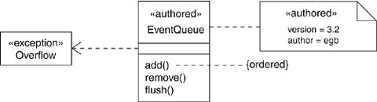

Collectively, these three extensibility mechanisms allow you to shape and grow the UML to your project's needs. These mechanisms also let the UML adapt to new software technology, such as the likely emergence of more powerful distributed programming languages. You can add new building blocks, modify the specification of existing ones, and even change their semantics. Naturally, it's important that you do so in controlled ways so that through these extensions, you remain true to the UML's purpose the communication of information.

Architecture:

Any real world system is used by different users. The users can be developers, testers, business people, analysts and many more. So before designing a system the architecture is made with different perspectives in mind. The most important part is to visualize the system from different viewer’s perspective. The better we understand the better we make the system.

UML plays an important role in defining different perspectives of a system. These perspectives are:

Design View
Implementation View
Process View
Deployment View
Usecase View
And the centre is the Use Case view which connects all these four. A Use case represents the functionality of the system. So the other perspectives are connected with use case.

Design of a system consists of classes, interfaces and collaboration. UML provides class diagram, object diagram to support this.
Implementation defines the components assembled together to make a complete physical system. UML component diagram is used to support implementation perspective.
Process defines the flow of the system. So the same elements as used in Design are also used to support this perspective.
Deployment represents the physical nodes of the system that forms the hardware. UML deployment diagram is used to support this perspective.

Software Development Life Cycle:

The Unified Software Development Process

A software development process is the set of activities needed to transform a user’s requirements into a software system.

Basic properties:

- use case driven
- architecture centric
- iterative and incremental

Use case Driven
Use cases

- capture requirements of the user,
- divide the development project into smaller subprojects,
- are constantly refined during the whole development process
- are used to verify the correctness of the implemented software

Architecture Centric:
- Find structures which are suitable to achieve the function specified in the use cases,
- understandable,
- maintainable,
- reusable for later extensions or newly discovered use cases and describe them, so that they can be communicated between developers and users.

Inception establishes the business rationale for the project and decides on the scope of the project.

Elaboration is the phase where you collect more detailed requirements, do high-level analysis and design to establish a baseline architecture and create the plan for construction.

Construction is an iterative and incremental process. Each iteration in this phase builds production- quality software prototypes , tested and integrated as subset of the requirements of the project.

Transition contains beta testing , performance tuning and user training.

UNIT-II

BASIC STRUCTURAL MODELING

Contents:

  - Classes

  - Relationships

  - Common Mechanisms

  - Diagrams

- Classes:

Terms and Concepts:

A class is a description of a set of objects that share the same attributes, operations, relationships, and semantics. Graphically, a class is rendered as a rectangle.

Names

Every class must have a name that distinguishes it from other classes. A name is a textual string. That name alone is known as a simple name; a path (qualified) name is the class name prefixed by the name of the package in which that class lives. A class may be drawn showing only its name
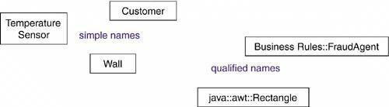

Fig : Simple and Path (qualified) Names

A class name may be text consisting of any number of letters, numbers, and certain punctuation marks (except for marks such as the colon, which is used to separate a class name and the name of its enclosing package) and may continue over several lines. In practice, class names are short nouns or noun phrases drawn from the vocabulary of the system you are modeling. Typically, you capitalize the first letter of every word in a class name, as in Customer or Temperature Sensor.

Attributes

An attribute is a named property of a class that describes a range of values that instances of the property may hold. A class may have any number of attributes or no attributes at all. An attribute represents some property of the thing you are modeling that is shared by all objects of that class. For example, every wall has a height, width, and thickness; you might model your customers in such a way that each has a name, address, phone number, and date of birth. Graphically, attributes are listed in a compartment just below the class name. Attributes may be
drawn showing only their names, as shown in Figure 4-3.

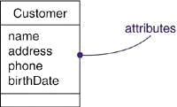

Figure 4-3 Attributes

An attribute name may be text, just like a class name. In practice, an attribute name is
a short noun or noun phrase that represents some property of its enclosing class.
Typically, you capitalize the first letter of every word in an attribute name except the
first letter, as in name or loadBearing.

You can specify other features of an attribute, such as marking it read-only or shared by all
objects of the class. You can further specify an attribute by stating its class and possibly a default initial value, as shown Figure 4-4.

Figure 4-4 Attributes and Their Class
Operations

An operation is the implementation of a service that can be requested from any object of the class to affect behavior. In other words, an operation is an abstraction of something you can do to an object that is shared by all objects of that class. A class may have any number of operations or no operations at all. For example, in a windowing library such as the one found in Java's awt package, all objects of the class Rectangle can be moved, resized, or queried for their properties. Often (but not always), invoking an operation on an object changes the object's data or state. Graphically, operations are listed in a compartment just below the class attributes. Operations may be drawn showing only their names as in figure 4.5

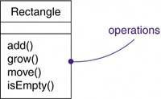

Figure :4.5 : Operations

An operation name may be text, just like a class name. In practice, an operation name is a short verb or verb phrase that represents some behavior of its enclosing class. Typically, you capitalize the first letter of every word in an operation name except the first letter, as in move or isEmpty.

You can specify an operation by stating its signature, which includes the name, type, and default value of all parameters and (in the case of functions) a return type shown in figure 4.6

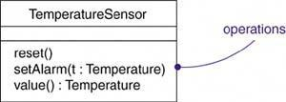

Figure :4.6 : Operations and Their Signatures

Organizing Attributes and Operations

When drawing a class, you don't have to show every attribute and every operation at once. In fact, in most cases, you can't (there are too many of them to put in one figure) and you probably shouldn't (only a subset of these attributes and operations are likely to be relevant to a specific view). For these reasons, you can elide a class, meaning that you can choose to show only some

or none of a class's attributes and operations. You can indicate that there are more attributes or properties than shown by ending each list with an ellipsis ("...").

To better organize long lists of attributes and operations, you can also prefix each group with a
descriptive category by using stereotypes, as shown in Figure 4-7.

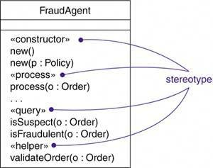

Figure 4-7 Stereotypes for Class Features

Responsibilities

A responsibility is a contract or an obligation of a class. When you create a class, you are making a statement that all objects of that class have the same kind of state and the same kind of behavior. At a more abstract level, these corresponding attributes and operations are just the features by which the class's responsibilities are carried out. A Wall class is responsible for knowing about height, width, and thickness; a FraudAgent class, as you might find in a credit card application, is responsible for processing orders and determining if they are legitimate, suspect, or fraudulent; a TemperatureSensor class is responsible for measuring temperature and raising an alarm if the temperature reaches a certain point.

A class may have any number of responsibilities, although, in practice, every well-structured class has at least one responsibility and at most just a handful. As you refine your models, you will translate these responsibilities into a set of attributes and operations that best fulfill the class's responsibilities.

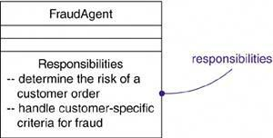
Graphically, responsibilities can be drawn in a separate compartment at the bottom of the class icon, as shown in Figure 4-8.

Figure 4-8 Responsibilities
Other Features

Attributes, operations, and responsibilities are the most common features you'll need when you
create abstractions. In fact, for most models you build, the basic form of these three features will
be all you need to convey the most important semantics of your classes. Sometimes, however,
you'll need to visualize or specify other features, such as the visibility of individual attributes and
operations.

Sometimes, you will want to separate the implementation of a class from its specification, and this can be expressed in the UML by using interfaces.

Finally, classes rarely stand alone. Rather, when you build models, you will typically focus on
groups of classes that interact with one another. In the UML, these societies of classes form
collaborations and are usually visualized in class diagrams.

Common Modeling Techniques

Modeling the Vocabulary of a System

You'll use classes most commonly to model abstractions that are drawn from the problem you are trying to solve or from the technology you are using to implement a solution to that problem. Each of these abstractions is a part of the vocabulary of your system, meaning that, together, they represent the things that are important to users and to implementers.

To model the vocabulary of a system,

Identify those things that users or implementers use to describe the problem or solution. Use CRC cards and use case-based analysis to help find these abstractions.
- For each abstraction, identify a set of responsibilities. Make sure that each class is crisply
defined and that there is a good balance of responsibilities among all your classes.
- Provide the attributes and operations that are needed to carry out these responsibilities for each class.

Figure 4,9 shows a set of classes drawn from a retail system, including Customer, Order, and Product. This figure includes a few other related abstractions drawn from the vocabulary of the problem, such as Shipment (used to track orders), Invoice (used to bill orders), and Warehouse (where products are located prior to shipment). There is also one solution-related abstraction, Transaction, which applies to orders and shipments.
Figure 4-9 Modeling the Vocabulary of a System
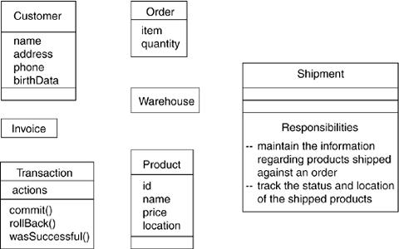

Modeling the Distribution of Responsibilities in a System

Once you start modeling more than just a handful of classes, you will want to be sure that your abstractions provide a balanced set of responsibilities. What this means is that you don't want any one class to be too big or too small. Each class should do one thing well. If you abstract classes that are too big, you'll find that your models are hard to change and are not very reusable. If you abstract classes that are too small, you'll end up with many more abstractions than you can reasonably manage or understand.

To model the distribution of responsibilities in a system,

Identify a set of classes that work together closely to carry out some behavior. Identify a set of responsibilities for each of these classes.
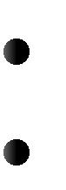
- Look at this set of classes as a whole, split classes that have too many responsibilities into smaller abstractions, collapse tiny classes that have trivial responsibilities into larger ones, and reallocate responsibilities so that each abstraction reasonably stands on its own.
- Consider the ways in which those classes collaborate with one another, and redistribute their responsibilities accordingly so that no class within a collaboration does too much or too little.

For example, Figure 4-10 shows a set of classes drawn from Smalltalk, showing the distribution of responsibilities among Model, View, and Controller classes.
Notice how all these classes Work together such that no one class does too much or too little.

Figure 4-10 Modeling the Distribution of Responsibilities in a System

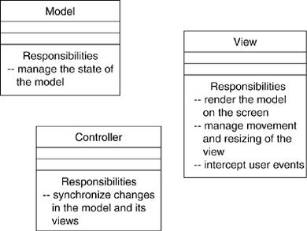

Modeling Nonsoftware Things

For example, the people who send invoices and the robots that automatically package orders for shipping from a warehouse might be a part of the workflow you model in a retail system.
Your application might not have any software that represents them

To model nonsoftware things,

Model the thing you are abstracting as a class.
If you want to distinguish these things from the UML's defined building blocks, create a new building block by using stereotypes to specify these new semantics and to give a distinctive visual cue.
If the thing you are modeling is some kind of hardware that itself contains software, consider modeling it as a kind of node as well, so that you can further expand on its structure.

As Figure 4-11shows, it's perfectly normal to abstract humans (like Accounts Receivable Agent) and hardware (like Robot) as classes, because each represents a set of objects with a common structure and a common behavior.

Figure 4-11 Modeling Nonsoftware Things

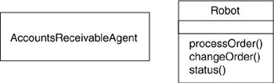

Modeling Primitive Types

At the other extreme, the things you model maybe drawn directly from the programming language you are using to implement a solution.
Typically, these abstractions involve primitive types, such as integers, characters, strings, and even enumeration types, that you might create yourself.

To model primitive types,

- Model the thing you are abstracting as a type or an enumeration, which is rendered using class notation with the appropriate stereotype.
- If you need to specify the range of values associated with this type, use constraints.

As Figure 4-12shows, these things can be modeled in the UML as types or enumerations, which are rendered just like classes but are explicitly marked via stereotypes. Things like integers (represented by the class Int) are modeled as types, and you can explicitly indicate the range of values these things can take on by using a constraint. Similarly, enumeration types, such as Boolean and Status, can be modeled as enumerations, with their individual values provided as attributes.

Figure 4-12 Modeling Primitive Types

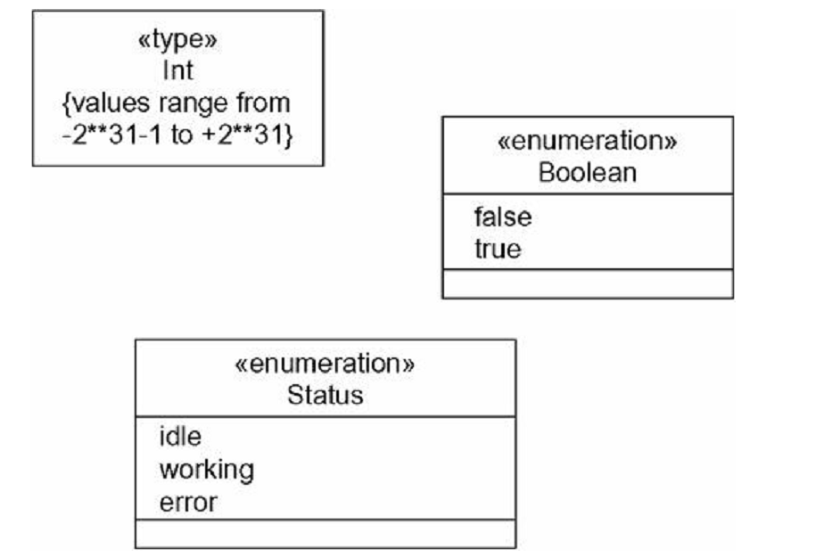

2.Relationships:

These three kinds of relationships cover most of the important ways in which things collaborate with one another. Not surprisingly, they also map well to the ways that are provided by most object-oriented programming languages to connect objects. The UML provides a graphical representation for each of these kinds of relationships, as Figure 5-1shows. This notation permits you to visualize relationships apart from any specific programming language, and in a way that lets you emphasize the most important parts of a relationship: its name, the things it connects, and its properties.

Figure 5-1 Relationships

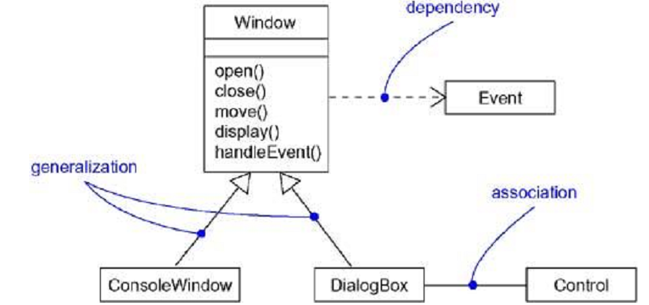

Terms and Concepts

A relationship is a connection among things. In object-oriented modeling, the three most important relationships are dependencies, generalizations, and associations. Graphically, a relationship is rendered as a path, with different kinds of lines used to distinguish the kinds of relationships.

Dependencies

A dependency is a relationship that states that one thing (for example, class Window) uses the information and services of another thing (for example, class Event), but not necessarily the reverse. Graphically, a dependency is rendered as a dashed directed line, directed to the thing being depended on. Choose dependencies when you want to show one thing using another.

Most often, you will use dependencies in the context of classes to show that one class uses another class as an argument in the signature of an operation; see Figure 5-2. This is very much a using relationship if the used class changes, the operation of the other class maybe affected, as well, because the used class may now present a different interface or behavior. In the UML you can also create dependencies among many other things, especially notes and packages.

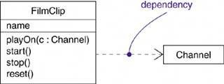

A dependency can have a name, although names are rarely needed unless you have a model with many dependencies and you need to refer to or distinguish among dependencies. More commonly, you'll use stereotypes to distinguish different flavors of dependencies.

Generalizations

A generalization is a relationship between a general kind of thing (called the superclass or parent) and a more specific kind of thing (called the subclass or child). Generalization is sometimes called an "is-a-kind-of" relationship: one thing (like the class BayWindow) is-a-kind-of a more general thing (for example, the class Window).

An objects of the child class may be used for a variable or parameter typed by the parent, but not the reverse. In other words, generalization means that the child is substitutable for the parent. A child inherits the properties of its parents, especially their attributes and operations. Often• but not always• the child has attributes and operations in addition to those found in its parents.

Graphically, generalization is rendered as a solid directed line with a large open arrowhead, pointing to the parent, as shown in Figure 5 3. Use generalizations when you want to show parent/child relationships.

A class may have zero, one, or more parents. A class that has no parents and one or more children is called a root class or a base class. A class that has no children is called a leaf class. A
class that has exactly one parent is said to use single inheritance; a class with more than one parent is said to use multiple inheritance.

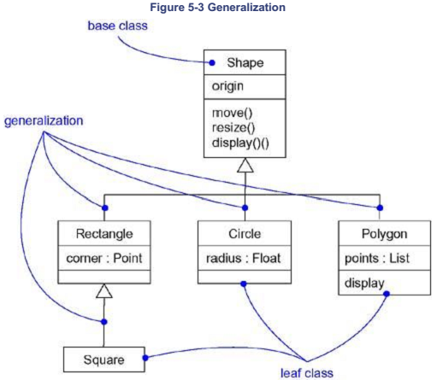

Associations

An association is a structural relationship that specifies that objects of one thing are connected to objects of another. Given an association connecting two classes, you can relate objects of one class to objects of the other class. It's quite legal to have both ends of an association circle back to the same class. This means that, given an object of the class, you can link to other objects of the same class. An association that connects exactly two classes is called a binary association. Although it's not as common, you can have associations that connect more than two classes; these are called n-ary associations.

Beyond this basic form, there are four adornments that apply to associations.

Name

An association can have a name, and you use that name to describe the nature of the relationship. So that there is no ambiguity about its meaning, you can give a direction to the name by providing a direction triangle that points in the direction you intend to read the name. as shown
in Figure 5-4.
Figure 5-4 Association Names

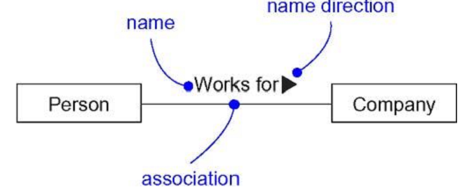

Role

When a class participates in an association, it has a specific role that it plays in that relationship; a role is just the face the class at the far end of the association presents to the class at the near end of the association. You can explicitly name the role a class plays in an association. The role played by an end of an association is called an end name (in UML1, it was called a role name). the class Person playing the role of employee is associated with the class Company playing the role of employer. In Figure 5-5, a Person playing the role of employee is associated with a Company playing the role of employer.

Figure 5-5 Roles

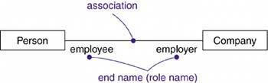

Multiplicity

An association represents a structural relationship among objects. In many modeling situations, it's important for you to state how many objects may be connected across an instance of an association. This "how many" is called the multiplicity of an association's role. It represents a range of integers specifying the possible size of the set of related objects.

The number of objects must be in the given range. You can show a multiplicity of exactly one (1), zero or one (0..1), many (0..*), or one or more (1..*). You can give an integer range (such as 2..5). You can even state an exact number (for example, 3, which is equivalent to 3..3).

Figure 5-6 Multiplicity
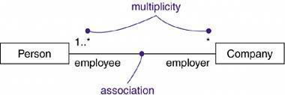
Aggregation

A plain association between two classes represents a structural relationship between peers, meaning that both classes are conceptually at the same level, no one more important than the other. Sometimes you will want to model a "whole/part" relationship, in which one class represents a larger thing (the "whole"), which consists of smaller things (the "parts"). This kind of relationship is called aggregation, which represents a "has-a" relationship meaning that an object of the whole has objects of the part. Aggregation is really just a special kind of association and is specified by adorning a plain association with an open diamond at the whole end, as shown in Figure 5-7.

Figure 5-7 Aggregation

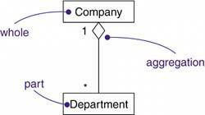

Common Modeling Techniques

Modeling Simple Dependencies

A common kind of dependency relationship is the connection between a class that uses another class as a parameter to an operation.

To model this using relationship,

Create a dependency pointing from the class with the operation to the class used as a parameter in the operation.
For example, Figure 5-8shows a set of classes drawn from a system that manages the assignment of students and instructors to courses in a university. A set of classes drawn from a system that manages the assignment of students and instructors to courses in a university. This figure shows a dependency from CourseSchedule to Course, because Course is used in both the add and remove operations of CourseSchedule.
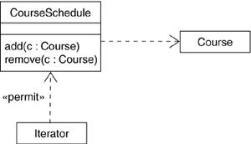
This figure shows one other dependency, this one not involving classes in operations but rather modeling a common C++ idiom. The dependency from Iterator shows that the Iterator uses the CourseSchedule; the CourseSchedule knows nothing about the Iterator. The dependencyis marked with a stereotype, which specifies that this is not a plain dependency, but, rather, it represents a friend, as in C++.

Modeling Single Inheritance

In modeling the vocabulary of your system, you will often run across classes that are structurally or behaviorally similar to others. You could model each of these as distinct and unrelated abstractions. A better way would be to extract any common structural and behavioral features and place them in more-general classes from which the specialized ones inherit.

To model inheritance relationships,

Given a set of classes, look for responsibilities, attributes, and operations that are common to two or more classes.
Elevate these common responsibilities, attributes, and operations to a more general class. If necessary, create a new class to which you can assign these elements (but be careful about introducing too many levels).
Specify that the more-specific classes inherit from the more-general class by placing a generalization relationship that is drawn from each specialized class to its more-general parent.
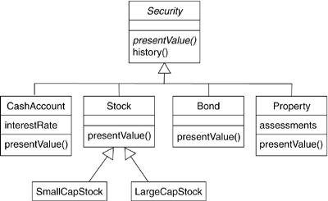

Figure 5-9 Inheritance Relationships

For example, Figure 5-9 shows a set of classes drawn from a trading application. You will find a generalization relationship from four classes• CashAccount, Stock, Bond, and Property• to the more-general class named Security. Security is the parent, and CashAccount, Stock, Bond, and Property are all children. Each of these specialized children is a kind of Security. You'll notice that Security includes two operations: present Value and history. Because Security is their parent, CashAccount, Stock, Bond, and Property all inherit these two operations, and for that matter, any other attributes and operations of Security that maybe elided in this figure.

You may notice that the names Security and presentValue are written a bit differently than others. There's a reason for this. When you build hierarchies as in the preceding figure, you often encounter nonleaf classes that are incomplete or are simply ones for which you don't want there to be any objects. Such classes are called abstract. You can specify a class as abstract in the UML by writing its name in italics, such as for the class Security.

This convention applies to operations such presentValue and means that the given operation provides a signature but is otherwise incomplete and so must be implemented by some method at a lower level of abstraction. In fact, as the figure shows, all four of the immediate children of Security are concrete (meaning that they are non abstract) and also provide a concrete implementation of the operation presentValue.

Your generalization/specialization hierarchies don't have to be limited to only two levels. In fact,
as the figure shows, it is common to have more than two layers of inheritance. SmallCapStock
and LargeCapStock are both children of Stock, which, in turn, is a child of Security. Security is therefore a base class because it has no parents. SmallCapStock and LargeCapStock are both leaf classes because they have no children. Stock has a parent as well as children, and so it is neither a root nor a leaf class.
.
Although it is not shown here, you can also create classes that have more than one parent. This
is called multiple inheritance and means that the given class has all the attributes, operations,
and associations of all its parents.

Modeling Structural Relationships

When you model with dependencies or generalization relationships, you may be modeling classes that represent different levels of importance or different levels of abstraction. Given a dependency between two classes, one class depends on another but the other class has no knowledge of the one.

To model structural relationships,

For each pair of classes, if you need to navigate from objects of one to objects of another, specify an association between the two. This is a data-driven view of associations.
For each pair of classes, if objects of one class need to interact with objects of the other class other than as local variables in a procedure or parameters to an operation, specify an association between the two. This is more of a behavior-driven view of associations.

- For each of these associations, specify a multiplicity (especially when the multiplicity is not *, which is the default), as well as role names (especially if they help to explain the model).

- If one of the classes in an association is structurally or organizationally a whole compared with the classes at the other end that look like parts, mark this as an aggregation by adorning the association at the end near the whole with a diamond.

Figure 5-10 Structural Relationships

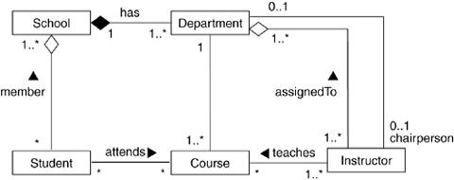

Figure 5-10shows a set of classes drawn from an information system for a school. Starting at the bottom left of this diagram, you will find the classes named Student, Course, and Instructor. There's an association between Student and Course, specifying that students attend courses. Furthermore, every student may attend any number of courses and every course may have any number of students.

Similarly, you'll find an association between Course and Instructor, specifying that instructors teach courses. For every course there is at least one instructor and every instructor May teach zero or more courses.

The relationships between School and the classes, Student and Department are a bit different. Here you'll see aggregation relationships. A school has zero or more students, each student maybe a registered member of one or more schools, a school has one or more departments, each department belongs to exactly one school. You could leave off the aggregation adornments and use plain associations, but by specifying that School is a whole and that Student and Department are some of its parts, you make clear which one is organizationally superior to the other.

Thus, schools are somewhat defined by the students and departments they have. Similarly, students and departments don't really standalone outside the school to which they belong. Rather, they get some of their identity from their school.

You'll also see that there are two associations between Department and Instructor. One of these associations specifies that every instructor is assigned to one or more departments and that each department has one or more instructors. This is modeled as an aggregation because organizationally, departments are at a higher level in the school's structure than are instructors.

The other association specifies that for every department, there is exactly one instructor who is
the department chair. The way this model is specified, an instructor can be the chair of no more
than one department and some instructors are not chairs of any department
3.Common Mechanisms:

Terms and Concepts

A note is a graphical symbol for rendering constraints or comments attached to an element or a collection of elements. Graphically, a note is rendered as a rectangle with a dog-eared corner, together with a textual or graphical comment.

A stereotype is an extension of the vocabulary of the UML, allowing you to create new kinds of building blocks similar to existing ones but specific to your problem. Graphically, a stereotype is rendered as a name enclosed by guillemets (French quotation marks of the form « »), placed above the name of another element.

Optionally the stereotyped element may be rendered by using a new icon associated with that stereotype.

A tagged value is a property of a stereotype, allowing you to create new information in an element bearing that stereotype. Graphically, a tagged value is rendered as a string of the form name = value within a note attached to the object.

A constraint is a textual specification of the semantics of a UML element, allowing you to add new rules or to modify existing ones. Graphically, a constraint is rendered as a string enclosed by brackets and placed near the associated element or connected to that element or elements by dependency relationships. As an alternative, you can render a constraint in a note.

Notes

A note that renders a comment has no semantic impact, meaning that its contents do not alter the meaning of the model to which it is attached. This is why notes are used to specify things like requirements, observations, reviews, and explanations, in addition to rendering constraints.

A note may contain any combination of text or graphics If your implementation allows it, you can put a live URL inside a note, or even link to or embed another document. In this way, you can use the UML to organize all the artifacts you might generate or use during development, as Figure 6-3 illustrates.
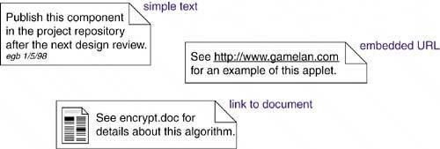
Figure 6-3 Notes
Other Adornments

Adornments are textual or graphical items that are added to an element's basic notation and are used to visualize details from the element's specification.

Most adornments are rendered by placing text near the element of interest or by adding a graphic symbol to the basic notation. However, sometimes you'll want to adorn an element with more detail than can be accommodated by simple text or graphics. In the case of such things as classes, components, and nodes, you can add an extra compartment below the usual compartments to provide this information, as Figure 6-4shows.

Figure 6-4 Extra Compartments

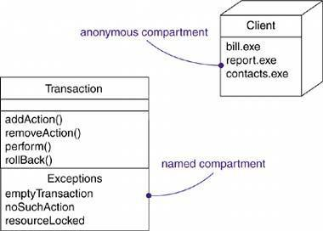

Stereotypes

The UML provides a language for structural things, behavioral things, grouping things, and notational things. These four basic kinds of things address the overwhelming majority of the systems you'll need to model. In its simplest form, a stereotype is rendered as a name enclosed by guillemets (for example, «name») and placed above the name of another element As a visual cue, you may define an icon for the stereotype and render that icon to the right of the name (if you are using the basic notation for the element) or use that icon as the basic symbol for the stereotyped item. All three of these approaches are illustrated in Figure 6-5.

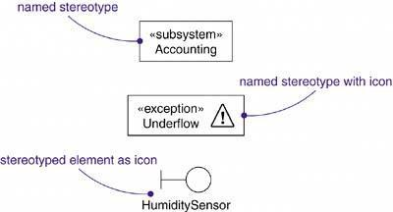
Figure 6-5 Stereotype
Tagged Values

Every thing in the UML has its own set of properties: classes have names, attributes, and operations; associations have names and two or more ends, each with its own properties; and so on. With stereotypes, you can add new things to the UML; with tagged values, you can add new properties to a stereotype.

A tagged value is not the same as a class attribute. Rather, you can think of a tagged value as metadata because its value applies to the element itself, not its instances. For example, as Figure 6-6 shows, you might want to specify the number of processors installed on each kind of node in a deployment diagram, or you might want to require that every component be stereotyped as a
Library if it is intended to be deployed on a client or a server.

Figure 6-6 Tagged Values

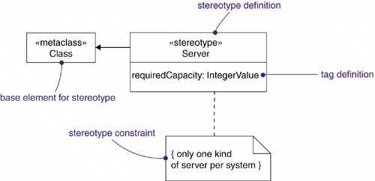

Constraints

Everything in the UML has its own semantics. Generalization (usually, if you know what's good for you) implies the Liskov substitution principle, and multiple associations connected to one class denote distinct relationships. With constraints, you can add new semantics or extend existing rules.

A constraint specifies conditions that must be held true for the model to be well -formed. For example, as Figure 6-7 shows, you might want to specify that, across a given association, communication is encrypted. Similarly, you might want to specify that among a set of associations, only one is manifest at a time.

A constraint is rendered as a string enclosed by brackets and placed near the associated element. This notation is also used as an adornment to the basic notation of an element to visualize parts of an element's specification that have no graphical cue. For example, some properties of associations (order and changeability) are rendered using constraint notation.
Figure 6-7 Constraint

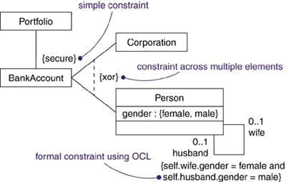

Standard Elements

The UML defines a number of standard stereotypes for classifiers, components, relationships, and other modeling elements. There is one standard stereotype, mainly of interest to tool builders, that lets you model stereotypes themselves.

Stereotype :Specifies that the classifier is a stereotype that maybe applied to other elements

You'll use this stereotype when you want to explicitly model the stereotypes you've defined for your project.The UML also specifies one standard tagged value that applies to all modeling elements.

documentation :Specifies a comment, description, or explanation of the element to which it is attached

You'll use this tagged value when you want to attach a comment directly to the specification of an element, such as a class.

Common Modeling Techniques

Modeling Comments

The most common purpose for which you'll use notes is to write down free-form observations, reviews, or explanations.

To model a comment,

Put your comment as text in a note and place it adjacent to the element to which it refers. You can show a more explicit relationship by connecting a note to its elements using a dependency relationship.
Remember that you can hide or make visible the elements of your model as you see fit. This means that you don't have to make your comments visible everywhere the elements to which it is attached are visible. Rather, expose your comments in your diagrams only insofar as you need to communicate that information in that context.
If your comment is lengthy or involves something richer than plain text, consider putting your comment in an external document and linking or embedding that document in a note attached to your model.
As your model evolves, keep those comments that record significant decisions that cannot be inferred from the model itself, and unless they are of historic interest discard the others.

For example, Figure 6-8 shows a model that's a work in progress of a class hierarchy, showing
some requirements that shape the model, as well as some notes from a design review. In this example, most of the comments are simple text (such as the note to Mary), but one of them (the note at the bottom of the diagram) provides a hyperlink to another document.

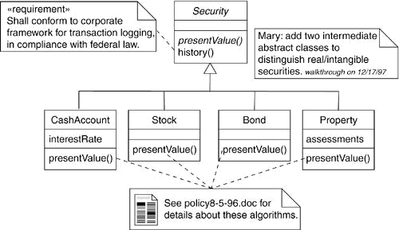
Figure 6-8 Modeling Comments
Modeling New Building Blocks

The UML's building blocks• classes, interfaces, collaborations, components, nodes, associations, and so on are generic enough to address most of the things you'll want to model. However, if you want to extend your modeling vocabulary or give distinctive visual cues to certain kinds of abstractions that often appear in your domain, you need to use stereotypes.

To model new building blocks,

- Make sure there's not already a way to express what you want by using basic UML. If you have a common modeling problem, chances are there's already some standard stereotype that will do what you want.
- If you're convinced there's no other way to express these semantics, identify the primitive thing in the UML that's most like what you want to model (for example, class, interface, component, node, association, and so on) and define a new stereotype for that thing.
- Specify the common properties and semantics that go beyond the basic element being stereotyped by defining a set of tagged values and constraints for the stereotype.
- If you want these stereotype elements to have a distinctive visual cue, define a new icon for the stereotype.
Figure 6-9 Modeling New Building Blocks.

For example, suppose you are using activity diagrams to model a business process involving the flow of coaches and teams through a sporting event. In this context, it would make sense to visually distinguish coaches and teams from one another and from the other things in this domain, such as events and divisions. As Figure 6-9 shows, there are two things that stand out Coach objects and Team objects. These are not just plain kinds of classes. Rather, they are now primitive building blocks that you can use in this context. You can create these new building
blocks by defining a coach and team stereotype and applying them to UML's classes. In this figure, the anonymous instances called :Coach and :Team appear using the icons associated with these stereotypes.

Modeling New Properties

The basic properties of the UML's building blocks attributes and operations for classes, the contents of packages

To model new properties,

First, make sure there's not already a way to express what you want by using basic UML. If you re convinced there's no other way to express these semantics, define a stereotype and add the new properties to the stereotype. The rules of generalization applytagged values defined for one kind of stereotype apply to its children.
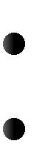
For example, suppose you want to tie the models you create to your project's configuration management system. Among other things, this means keeping track of the version number, current check in/check out status, and perhaps even the creation and modification dates of each subsystem. Because this is process-specific information, it is not a basic part of the UML, although you can add this information as tagged values. Furthermore, this information is not just a class attribute either. A subsystem's version number is part of its metadata, not part of the model.
Figure 6-10 shows four subsystems, each of which has been extended to include its version
number and status. In the case of the Billing subsystem, one other tagged value is shown•
the person who has currently checked out the subsystem.

Figure 6-10 Modeling New Properties
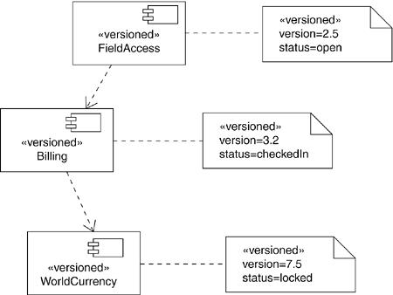
Modeling New Semantics

When you create a model using the UML, you work within the rules the UML lays down. However, if you find yourself needing to express new semantics about which the UML is silent or that you need to modify the UML's rules, then you need to write a constraint.

To model new semantics,

First, make sure there's not already a way to express what you want by using basic UML. If you re convinced there's no other way to express these semantics, write your new semantics in a constraint placed near the element to which it refers. You can show a more explicit relationship by connecting a constraint to its elements using a dependency relationship.
If you need to specify your semantics more precisely and formally, write your new semantics using OCL.

For example, Figure 6-11 models a small part of a corporate human resources system. This diagram shows that each Person may be a member of zero or more Departments and that each Department must have at least one Person as a member. This diagram goes on to indicate that each Department must have exactly one Person as a manager and every Person may be the manager of zero or more Departments. All of these semantics can be expressed using simple UML. However, to assert that a manager must also be a member of the department is something that cuts across multiple associations and cannot be expressed using simple UML.

To state this invariant, you have to write a constraint that shows the manager as a subset of the
members of the Department, connecting the two associations and the constraint by a
dependency from the subset to the superset.

Figure 6-11 Modeling New Semantics

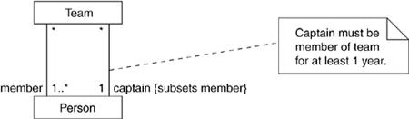

4.Diagrams:

Terms and Concepts

A system is a collection of subsystems organized to accomplish a purpose and described by a set of models, possibly from different viewpoints.

A subsystem is a grouping of elements, some of which constitute a specification of the behavior offered by the other contained elements.

A model is a semantically closed abstraction of a system, meaning that it represents a complete and self-consistent simplification of reality, created in order to better understand the system. In the context of architecture,

A view is a projection into the organization and structure of a system's model, focused on one aspect of that system.

A diagram is the graphical presentation of a set of elements, most often rendered as a connected graph of vertices (things) and arcs (relationships).

In modeling real systems, no matter what the problem domain, you'll find yourself creating the same kinds of diagrams, because they represent common views into common models. Typically, you'll view the static parts of a system using one of the following diagrams.

- Class diagram
- Component diagram
- Composite structure diagram
- Object diagram
- Deployment diagram
- Artifact diagram

You'll often use five additional diagrams to view the dynamic parts of a system.

- Use case diagram
- Sequence diagram
- Communication diagram
- State diagram
- Activity diagram

The UML defines these nine kinds of diagrams.

Every diagram you create will most likely be one of these nine or occasionally of another kind, defined for your project or organization. Every diagram must have a name that's unique in its context so that you can refer to a specific diagram and distinguish one from another. For anything but the most trivial system, you'll want to organize your diagrams into packages.
Structural Diagrams

The UML's structural diagrams exist to visualize, specify, construct, and document the static aspects of a system. You can think of the static aspects of a system as representing its relatively stable skeleton and scaffolding. Just as the static aspects of a house encompass the existence and placement of such things as walls, doors, windows, pipes, wires, and vents, so too do the static aspects of a software system encompass the existence and placement of such things as classes, interfaces, collaborations, components, and nodes.

The UML's structural diagrams are roughly organized around the major groups of things you'll find when modeling a system.

1.Class diagram Classes, interfaces, and collaborations

2.Component diagram Components

3.Object diagram Objects

4.Deployment diagram Nodes

Class Diagram

A class diagram shows a set of classes, interfaces, and collaborations and their relationships. Class diagrams are the most common diagram found in modeling object-oriented systems. You use class diagrams to illustrate the static design view of a system. Class diagrams that include active classes are used to address the static process view of a system.

Object Diagram

An object diagram shows a set of objects and their relationships. You use object diagrams to illustrate data structures, the static snapshots of instances of the things found in class diagrams. Object diagrams address the static design view or static process view of a system just as do class diagrams, but from the perspective of real or prototypical cases.

Component Diagram

A component diagram shows a set of components and their relationships. You use component diagrams to illustrate the static implementation view of a system. Component diagrams are related to class diagrams in that a component typically maps to one or more classes, interfaces, or collaborations.

Deployment Diagram

A deployment diagram shows a set of nodes and their relationships. You use deployment diagrams to illustrate the static deployment view of an architecture. Deployment diagrams are related to component diagrams in that a node typically encloses one or more components.
Behavioral Diagrams

The UML's behavioral diagrams are used to visualize, specify, construct, and document the dynamic aspects of a system. You can think of the dynamic aspects of a system as representing its changing parts. Just as the dynamic aspects of a house encompass airflow and traffic through the rooms of a house, so too do the dynamic aspects of a software system encompass such things as the flow of messages over time and the physical movement of components across a network.

The UML's behavioral diagrams are roughly organized around the major ways you can model the dynamics of a system.

1.Use case diagram Organizes the behaviors of the system

2.Sequence diagram Focuses on the time ordering of messages

3.Collaboration diagram Focuses on the structural organization of objects that send and receive messages
4.State diagram Focuses on the changing state of a system driven by events

5.Activity diagram Focuses on the flow of control from activity to activity

Use Case Diagram
A use case diagram shows a set of use cases and actors (a special kind of class) and their relationships. You apply use case diagrams to illustrate the static use case view of a system. Use
case diagrams are especially important in organizing and modeling the behaviors of a system.

The next two diagrams and the last two diagrams are semantically equivalent, which means that you can model the dynamics of a system using one kind of behavioral diagram and then transform it to another kind of diagram without loss of information.

Interaction Diagram
Interaction diagram is the collective name given to sequence diagrams and collaboration diagrams. All sequence diagrams and collaborations are interaction diagrams, and an interaction diagram is either a sequence diagram or a collaboration diagram.

Sequence Diagram
A sequence diagram is an interaction diagram that emphasizes the time ordering of messages. A sequence diagram shows a set of objects and the messages sent and received by those objects. The objects are typically named or anonymous instances of classes, but may also represent instances of other things, such as collaborations, components, and nodes. You use sequence diagrams to illustrate the dynamic view of a system.

Collaboration Diagram
A collaboration diagram is an interaction diagram that emphasizes the structural organization of the objects that send and receive messages. A collaboration diagram shows a set of objects, links among those objects, and messages sent and received by those objects. The objects are typically named or anonymous instances of classes, but may also represent instances of other things, such as collaborations, components, and nodes. You use collaboration diagrams to illustrate the dynamic view of a system.
Note
Sequence and collaboration diagrams are isomorphic, meaning that you can convert from one to the other without loss of information.

Statechart Diagram
A statechart diagram shows a state machine, consisting of states, transitions, events, and activities. You use statechart diagrams to illustrate the dynamic view of a system. They are especially important in modeling the behavior of an interface, class, or collaboration. Statechart diagrams emphasize the event-ordered behavior of an object, which is especially useful in modeling reactive systems.

Activity Diagram
An activity diagram shows the flow from activity to activity within a system. An activity shows a set of activities, the sequential or branching flow from activity to activity, and objects that act and are acted upon. You use activity diagrams to illustrate the dynamic view of a system. Activity diagrams are especially important in modeling the function of a system. Activity diagrams emphasize the flow of control among objects.

Common Modeling Techniques

Modeling Different Views of a System

When you model a system from different views, you are in effect constructing your system simultaneously from multiple dimensions. By choosing the right set of views, you set up a process that forces you to ask good questions about your system and to expose risks that need to be attacked.

To model a system from different views,

Decide which views you need to best express the architecture of your system and to expose the technical risks to your project. The five views of an architecture described earlier are a good starting point.
For each of these views, decide which artifacts you need to create to capture the essential details of that view. For the most part, these artifacts will consist of various UML diagrams.
As part of your process planning, decide which of these diagrams you'll want to put under some sort of formal or semi-formal control. These are the diagrams for which you'll want to schedule reviews and to preserve as documentation for the project.
- Allow room for diagrams that are thrown away. Such transitory diagrams are still useful for exploring the implications of your decisions and for experimenting with changes.

For example, if you are modeling a simple monolithic application that runs on a single machine, you might need only the following handful of diagrams.
Use case view | Use case diagrams
Design view | Class diagrams (for structural modeling)
Interaction view | Interaction diagrams (for behavioral modeling)
Implementation view | Composite structure diagrams
Deployment view | None required

Similarly, if yours is a client/server system, you'll probably want to include component diagrams and deployment diagrams to model the physical details of your system.

Finally, if you are modeling a complex, distributed system, you'll need to employ the full range of the UML's diagrams in order to express the architecture of your system and the technical risks to your project, as in the following.

Modeling Different Levels of Abstraction

Not only do you need to view a system from several angles, you'll also find people involved in development who need the same view of the system but at different levels of abstraction

To model a system at different levels of abstraction by presenting diagrams with different levels of detail,

- Consider the needs of your readers, and start with a given model.
- If your reader is using the model to construct an implementation, she'll need diagrams that are at a lower level of abstraction, which means that they'll need to reveal a lot of detail. If she is using the model to present a conceptual model to an end user, she'll need diagrams that are at a higher level of abstraction, which means that they'll hide a lot of detail.

- Depending on where you land in this spectrum of low-to-high levels of abstraction, create
a diagram at the right level of abstraction by hiding or revealing the following four
categories of things from your model:

1. Building blocks and relationships:
Hide those that are not relevant to the intent of your diagram or the needs of your reader.
2. Adornments:
Reveal only the adornments of these building blocks and relationships that are essential to understanding your intent.
3. Flow:
In the context of behavioral diagrams, expand only those messages or transitions that are essential to understanding your intent.
4. Stereotypes:
In the context of stereotypes used to classify lists of things, such as attributes and operations, reveal only those stereotyped items that are essential to understanding your intent.

The main advantage of this approach is that you are always modeling from a common semantic repository. The main disadvantage of this approach is that changes from diagrams at one level of abstraction may make obsolete diagrams at a different level of abstraction.

To model a system at different levels of abstraction by creating models at different levels of
abstraction,

- Consider the needs of your readers and decide on the level of abstraction that each should view, forming a separate model for each level.

- In general, populate your models that are at a high level of abstraction with simple abstractions and your models that are at a low level of abstraction with detailed abstractions. Establish trace dependencies among the related elements of different models.

- In practice, if you follow the five views of an architecture, there are four common situations you'll encounter when modeling a system at different levels of abstraction:

1. Use cases and their realization:
Use cases in a use case model will trace to collaborations in a design model.
2. Collaborations and their realization:
Collaborations will trace to a society of classes that work together to carry out the collaboration.
3. Components and their design:
Components in an implementation model will trace to the elements in a design model.
4. Nodes and their components:
Nodes in a deployment model will trace to components in an implementation model.

For example, suppose you are modeling a system for Web commerce• one of the main use cases of such a system would be for placing an order. If you're an analyst or an end user, you'd probably create some interaction diagrams at a high level of abstraction that show the action of
placing an order, as in Figure 7-1.

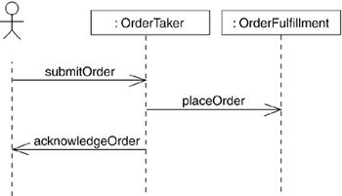
Figure 7-1 Interaction Diagram at a High Level of Abstraction

On the other hand, a programmer responsible for implementing this scenario would have to build on this diagram, expanding certain messages and adding other players in this interaction, as in Figure 7-2.

Figure 7-2 Interaction at a Low Level of Abstraction

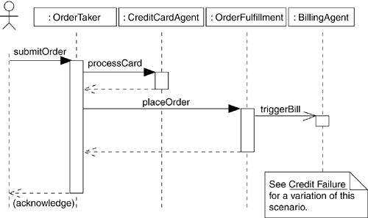

Modeling Complex Views

No matter how you break up your models, there are times when you'll find it necessary to create
large and complex diagrams. If you were to show this model at a higher level of abstraction by eliding some detail, you'd lose the information necessary to make these insights.

To model complex views,

First, convince yourself that there is no meaningful way to present this information at a higher level of abstraction, perhaps eliding some parts of the diagram and retaining the detail in other parts.
If you've hidden as much detail as you can and your diagram is still complex, consider grouping some of the elements in packages or in higher-level collaborations, then render only those packages or collaborations in your diagram.
If your diagram is still complex, use notes and color as visual cues to draw the reader's attention to the points you want to make.
If your diagram is still complex, print it in its entirety and hang it on a convenient large wall. You lose the interactivity that an online version of the diagram brings, but you can step back from the diagram and study it for common patterns.

ADVANCED STRUCTURAL MODELING

- 1. Advanced Classes
- 2. Advanced Relationships
- 3. Interface, Type and Role
- 4. Packages

1.Advanced Classes:

The UML provides a representation for a number of advanced properties, as Figure 9-1 shows.
This notation permits you to visualize, specify, construct, and document a class to any level of
detail you wish, even sufficient to support forward and reverse engineering of models and code.

Figure 9-1 Advanced Classes

Terms and Concepts

A classifier is a mechanism that describes structural and behavioral features. Classifiers include classes, associations, interfaces, datatypes, signals, components, nodes, use cases, and subsystems.

Classifiers

When you model, you'll discover abstractions that represent things in the real world and things in your solution. For example, if you are building a Web-based ordering system, the vocabulary of your project will likely include a Customer class (representing people who order products) and a

Transaction class (an implementation artifact, representing an atomic action). In the deployed system, you might have a Pricing component, with instances living on every client node. Each of these abstractions will have instances; separating the essence and the instance of the things in your world is an important part of modeling.

The most important kind of classifier in the UML is the class. A class is a description of a set of objects that share the same attributes, operations, relationships, and semantics. Classes are not the only kind of classifier, however. The UML provides a number of other kinds of classifiers to help you model.

Graphically, the UML distinguishes among these different classifiers, as Figure 9-2 shows.

Figure 9-2 Classifiers

Subsystem A component that represents a major part of a system
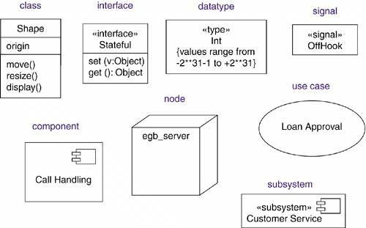

Visibility

One of the design details you can specify for an attribute or operation is visibility. The visibility of a feature specifies whether it can be used by other classifiers. In the UML, you can specify any of four levels of visibility.

1. public Any outside classifier with visibility to the given classifier can use the feature;
specified by prepending the symbol +.

2. protected Any descendant of the classifier can use the feature; specified by prepending the symbol #.

3. private Only the classifier itself can use the feature; specified by prepending the symbol -.

3. package Only classifiers declared in the same package can use the feature; specified by
prepending the symbol ~.
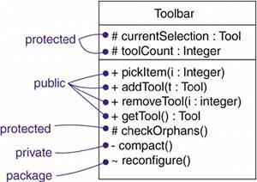

Scope

Another important detail you can specify for a classifier's attributes and operations is its owner
scope. The owner scope of a feature specifies whether the feature appears in each instance of
the classifier or whether there is just a single instance of the feature for all instances of the
classifier. In the UML, you can specify two kinds of owner scope.

As Figure 9-4 (a simplification of the first figure) shows, a feature that is classifier scoped is rendered by underlining the feature's name. No adornment means that the feature is instance scoped.
Figure 9-4 Owner Scope

In general, most features of the classifiers you model will be instance scoped. The most common
use of classifier scoped features is for private attributes that must be shared among a set of instances (and with the guarantee that no other instances have access to that attribute), such as for generating unique IDs among all instances of a given classifier, and for operations that create instances of the class.

Abstract, Root, Leaf, and Polymorphic Elements

You use generalization relationships to model a lattice of classes, with more-generalized abstractions at the top of the hierarchy and more-specific ones at the bottom. Within these hierarchies, it's common to specify that certain classes are abstractmeaning that they may not have any direct instances. In the UML, you specify that a class is abstract by writing its name in italics. Icon, RectangularIcon, and ArbitraryIcon are all abstract classes. By contrast, a concrete class (such as Button and OKButton) may have direct instances. For example, as Figure 9-5 shows, Icon, RectangularIcon, and ArbitraryIcon are all abstract classes. By contrast, a concrete class (such as Button and OKButton) is one that may have direct instances.

Figure 9-5 Abstract and Concrete Classes and Operations
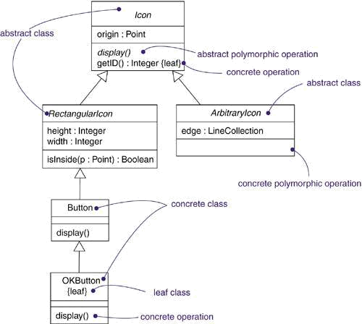

Whenever you use a class, you'll probably want to inherit features from other, more-general, classes, and have other, more-specific, classes inherit features from it. These are the normal semantics you get from classes in the UML. However, you can also specify that a class may have no children. Such an element is called a leaf class and is specified in the UML by writing the property leaf below the class's name. For example, in the figure, OKButton is a leaf class, so it may have no children.

Less common but still useful is the ability to specify that a class may have no parents. Such an element is called a root class, and is specified in the UML by writing the property root below the class's name. For example, in the figure, Icon is a root class. Especially when you have multiple, independent inheri-tance lattices, it's useful to designate the head of each hierarchy in this manner.

Multiplicity

Whenever you use a class, it's reasonable to assume that there may be any number of instances of that class (unless, of course, it is an abstract class and may not have any direct instances, although there may be any number of instances of its concrete children). multiplicity of a class by writing a multiplicity expression in the upper-right corner of the class icon. For example, in Figure 9-6, NetworkController is a singleton class. Similarly, there are exactly three instances of the class ControlRod in the system.

Figure 9-6 Multiplicity

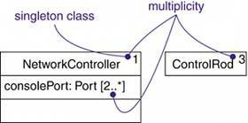

Multiplicity applies to attributes, as well. You can specify the multiplicity of an attribute by writing a suitable expression in brackets just after the attribute name. For example, in the figure, there are two or more consolePort instances in the instance of NetworkController.

Attributes

At the most abstract level, when you model a class's structural features (that is, its attributes), you simply write each attribute's name.

visibility] name

[':' type] ['[' multiplicity] ']'] ['=' initial-value]

[property-string {',' property-string}]

For example, the following are all legal attribute declarations:

Operations

At the most abstract level, when you model a class's behavioral features. ou can also specify the parameters, return type, concurrency semantics, and other properties of each operation. Collectively, the name of an operation plus its parameters (including its return type, if any) is called the operation's signature.

[visibility] name ['(' parameter-list ')'] [':' return-type]

[property-string {',' property-string}]

For example, the following are all legal operation declarations:

Template Classes

A template is a parameterized element. In such languages as C++ and Ada, you can write template classes, each of which defines a family of classes.

A template may include slots for classes, objects, and values, and these slots serve as the template's parameters. You can't use a template directly; you have to instantiate it first. Instantiation involves binding these formal template parameters to actual ones. For a template class, the result is a concrete class that can be used just like any ordinary class.

The most common use of template classes is to specify containers that can be instantiated for specific elements, making them type-safe. For example, the following C++ code fragment declares a parameterized Map class.

template<class Item, class VType, int Buckets>

class Map { public:

virtual map(const Item&, const VType&); virtual Boolean isMappen(const Item&) const;
...
};

You might then instantiate this template to map Customer objects to Order objects.

m : Map<Customer, Order, 3>;

You can model template classes in the UML as well. As Figure 9-7 shows, you render a template class just as you do an ordinary class, but with an additional dashed box in the upper right corner of the class icon, which lists the template parameters.

Figure 9-7 Template Classes
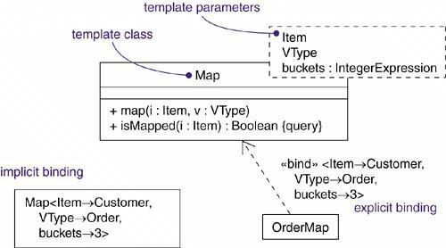

As the figure goes on to show, you can model the instantiation of a template class in two ways. First, you can do so implicitly, by declaring a class whose name provides the binding. Second, you can do so explicitly, by using a dependency stereotyped as bind, which specifies that the source instantiates the target template using the actual parameters.

Standard Elements

All of the UML's extensibility mechanisms apply to classes. Most often, you'll use tagged values to extend class properties (such as specifying the version of a class) and stereotypes to specify new kinds of components (such as model- specific components).

The UML defines four standard stereotypes that apply to classes.

Common Modeling Techniques

Modeling the Semantics of a Class

To model the semantics of a class, choose among the following possibilities, arranged from informal to formal.

Specify the responsibilities of the class. A responsibility is a contract or obligation of a type or class and is rendered in a note attached to the class, or in an extra compartment in the class icon.
Specify the semantics of the class as a whole using structured text, rendered in a note (stereotyped as semantics) attached to the class.
Specify the body of each method using structured text or a programming language, rendered in a note attached to the operation by a dependency relationship.
Specify the pre- and postconditions of each operation, plus the invariants of the class as a whole, using structured text. These elements are rendered in notes (stereotyped as precondition, postcondition, and invariant) attached to the operation or class by a dependency relationship.
Specify a state machine for the class. A state machine is a behavior that specifies the sequences of states an object goes through during its lifetime in response to events, together with its responses to those events.
Specify internal structure of the class.
Specify a collaboration that represents the class. A collaboration is a society of roles and other elements that work together to provide some cooperative behavior that's bigger than the sum of all the elements. A collaboration has a structural part as well as a dynamic part, so you can use collaborations to specify all dimensions of a class's semantics.
Specify the pre- and postconditions of each operation, plus the invariants of the class as a whole, using a formal language such as OCL.
Pragmatically, you'll end up doing some combination of these approaches for the different abstractions in your system.

2.Advanced Relationships

The UML provides a representation for a number of advanced properties, as Figure 10-1 shows. This notation permits you to visualize, specify, construct, and document webs of relationships to
any level of detail you wish, even sufficient to support forward and reverse engineering of models and code.

Terms and Concepts

A relationship is a connection among things. In object-oriented modeling, the four most important relationships are dependencies, generalizations, associations, and realizations. Graphically, a relationship is rendered as a path, with different kinds of lines used to distinguish the different relationships.

Dependencies

A dependency is a using relationship, specifying that a change in the specification of one thing (for example, class SetTopController) may affect another thing that uses it (for example, class ChannelIterator), but not the reverse. Graphically, a dependency is rendered as a dashed line, directed to the thing that is depended on. Apply dependencies when you want to show one thing using another.

A plain, unadorned dependency relationship is sufficient for most of the using relationships you'll encounter. However, if you want to specify a shade of meaning, the UML defines a number of stereotypes that may be applied to dependency relationships. There are a number of stereotypes, which can be organized into several groups.

First, there are stereotypes that apply to dependency relationships among classes and objects in class diagrams.
1. Bind Specifies that the source instantiates the target template using the given actual
parameters

You'll use bind when you want to model the details of template classes. For example, the relationship between a template container class and an instantiation of that class would be modeled as a bind dependency. Bind includes a list of actual arguments that map to the formal arguments of the template.

2. Derive Specifies that the source may be computed from the target
You'll use derive when you want to model the relationship between two attributes or two associations, one of which is concrete and the other is conceptual. For example, a Person class might have the attribute BirthDate (which is concrete), as well as the attribute Age (which can be derived from BirthDate, so is not separately manifest in the class). You'd show the relationship between Age and BirthDate by using a derive dependency, showing Age derived from BirthDate.

3. Permit Specifies that the source is given special visibility into the target

You'll use friend when you want to model relationships such as found with C++ friend classes.

4. InstanceOf Specifies that the source object is an instance of the target classifier. Ordinarily shown using text notation in the form source : Target

5. Instantiate Specifies that the source creates instances of the target

These last two stereotypes let you model class/object relationships explicitly. You'll use instanceOf when you want to model the relationship between a class and an object in the same diagram, or between a class and its metaclass. You'll use instantiate when you want to specify which element creates objects of another.

6. Powertype Specifies that the target is a powertype of the source; a powertype is a classifier whose objects are the children of a given parent

You'll use powertype when you want to model classes that cover other classes, such as you'll find when modeling databases.

7. Refine Specifies that the source is at a finer degree of abstraction than the target

You'll use refine when you want to model classes that are essentially the same but at different levels of abstraction. For example, during analysis, you might encounter a Customer class which, during design, you refine into a more detailed Customer class, complete with its implementation
8. Use Specifies that the semantics of the source element depends on the semantics of the
public part of the target
You'll apply use when you want to explicitly mark a dependency as a using relationship, in
contrast to the shades of dependencies other stereotypes provide.

There are two stereotypes that apply to dependency relationships among packages.

1. Import Specifies that the public contents of the target package enter the public namespace of the source, as if they had been declared in the source.

2.Access Specifies that the public contents of the target package enter the private namespace of the source. The unqualified names may be used within the source, but they may not be re-exported.

You'll use access and import when you want to model the relationships among packages. Between two peer packages, the elements in one cannot reference the elements in the other unless there's an explicit access or import dependency. For example, suppose a target package T contains the class C. If you specify an access dependency from Sto T, then the elements of S can reference C, using the fully qualified name T::C. If you specify an import dependency from S to T, then the elements of S can reference C using just its simple name.

Two stereotypes apply to dependency relationships among use cases:

1. Extend Specifies that the target use case extends the behavior of the source

2.Include Specifies that the source use case explicitly incorporates the behavior of another use case at a location specified by the source

You'll use extend and include (and simple generalization) when you want to decompose use
cases into reusable parts.

You'll encounter three stereotypes when modeling interactions among objects.

You'll use become and copy when you want to show the role, state, or attribute value of one
object at different points in time or space. You'll use call when you want to model the calling
dependencies among operations.

One stereotype you'll encounter in the context of interactions among objects is

1. Send Specifies that the source class sends the target event

You'll use send when you want to model an operation (such as found in the action associated
with a state transition) dispatching a given event to a target object (which in turn might have an
associated state machine). The send dependency in effect lets you tie independent state machines together.

Finally, one stereotype that you'll encounter in the context of organizing the elements of your system into subsystems and models is

1. TRace Specifies that the target is a historical predecessor of the source from an earlier stage of development

You'll use trace when you want to model the relationships among elements in different models. For example, in the context of a system's architecture, a use case in a use case model (representing a functional requirement) might trace to a package in the corresponding design model (representing the artifacts that realize that use case).

Generalizations

A generalization is a relationship between a general classifier (called the superclass or parent) and a more specific classifier (called the subclass or child). For example, you might encounter the general class Window with its more specific subclass, MultiPaneWindow. With a generalization relationship from the child to the parent, the child (MultiPaneWindow) will inherit all the structure and behavior of the parent (Window).

Most of the time, you'll find single inheritance sufficient. A class that has exactly one parent is said to use single inheritance. There are times, however, when multiple inheritance is better, and you can model those relationships, as well, in the UML. For example, Figure 10-2 shows a set of classes drawn from a financial services application. You see the class Asset with three children: BankAccount, RealEstate, and Security. Two of these children (BankAccount and Security) have their own children. For example, Stock and Bond are both children of Security.

Figure 10-2 Multiple Inheritance

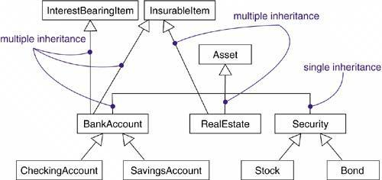

Two of these children (BankAccount and RealEstate) inherit from multiple parents. RealEstate, for example, is a kind of Asset, as well as a kind of InsurableItem, and BankAccount is a kind of Asset, as well as a kind of InterestBearingItem and an InsurableItem. Parents, such as InterestBearingItem and InsurableItem, are called mixins because they don't stand alone but, rather, are intended to be mixed in with other parents (such as Asset) to form children from these various bits of structure and behavior.

A plain, unadorned generalization relationship is sufficient for most of the inheritance relationships you'll encounter. However, if you want to specify a shade of meaning, the UML defines four constraints that may be applied to generalization relationships:

First, there is the one stereotype.
?implementation Specifies that the child inherits the implementation of the parent but does
not make public nor support its interfaces, thereby violating substitutability
Next, there are four standard constraints that apply to generalization relationships.
You'll use implementation when you want to model private inheritance, such as found in C++.

1. complete Specifies that all children in the generalization have been specified in the model
(although some may be elided in the diagram) and that no additional children are
permitted

2.incomplete Specifies that not all children in the generalization have been specified (even if
some are elided) and that additional children are permitted

Unless otherwise stated, you can assume that any diagram shows only a partial view of an inheritance lattice and so is elided. However, elision is different from the completeness of a model. Specifically, you'll use the complete constraint when you want to show explicitly that you've fully specified a hierarchy in the model (although no one diagram may show that hierarchy); you'll use incomplete to show explicitly that you have not stated the full specification of the hierarchy in the model (although one diagram may show everything in the model).

3. disjoint Specifies that objects of the parent may have no more than one of the children as

a type. For example, class Person can be specialized into disjoint classes Man and
Woman.

4.overlapping Specifies that objects of the parent may have more than one of the children as a
type. For example, class Vehicle can be specialized into overlapping subclasses
LandVehicle and WaterVehicle (an amphibious vehicle is both).
These two constraints apply only in the context of multiple inheritance. You'll use disjoint and overlapping when you want to distinguish between static classification (disjoint) and dynamic classification (overlapping).
Associations

An association is a structural relationship, specifying that objects of one thing are connected to objects of another. For example, a Library class might have a one-to-many association to a Book class, indicating that each Book instance is owned by one Library instance. Furthermore, given a Book, you can find its owning Library, and given a Library, you can navigate to all its Books. Graphically, an association is rendered as a solid line connecting the same or different classes. You use associations when you want to show structural relationships.

Navigation

Given a plain, unadorned association between two classes, such as Book and Library, it's possible to navigate from objects of one kind to objects of the other kind. Unless otherwise specified, navigation across an association is bidirectional. For example, as Figure 10-3 shows, when modeling the services of an operating system, you'll find an association between User and Password objects. Given a User, you'll want to be able to find the corresponding Password objects; but given a Password, you don't want to be able to identify the corresponding User. You can explicitly represent the direction of navigation by adorning an association with an arrowhead pointing to the direction of traversal.

Figure 10-3 Navigation

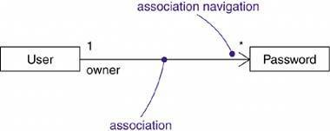

Visibility

Given an association between two classes, objects of one class can see and navigate to objects of the other unless otherwise restricted by an explicit statement of navigation. However, there are circumstances in which you'll want to limit the visibility across that association relative to objects outside the association.

There is an association between UserGroup and User and another between User and Password. Given a User object, it's possible to identify its corresponding Password objects. However, a Password is private to a User, so it shouldn't be accessible from the outside (unless, of course, the User explicitly exposes access to the Password,

For example, as Figure 10-4 shows, there is an association between UserGroup and User and another between User and Password. Given a User object, it's possible to identify its corresponding Password objects. However, a Password is private to a User, so it shouldn't be accessible from the outside (unless, of course, the User explicitly exposes access to the Password, perhaps through some public operation). Therefore, as the figure shows, given a UserGroup object, you can navigate to its User objects (and vice versa), but you cannot in turn see the User object's Password objects; they are private to the User.

Figure 10-4 Visibility

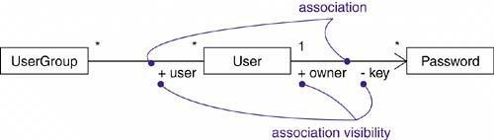

Qualification

In the context of an association, one of the most common modeling idioms you'll encounter is the problem of lookup. Given an object at one end of an association, how do you identify an object or set of objects at the other end? For example, consider the problem of modeling a work desk at a manufacturing site at which returned items are processed to be fixed .

As Figure 10-5 shows, you'd model an association between two classes, WorkDesk and ReturnedItem. In the context of the WorkDesk, you'd have a jobId that would identify a particular ReturnedItem. In that sense, jobId is an attribute of the association. It's not a feature of ReturnedItem because items really have no knowledge of things like repairs or jobs. Then, given an object of WorkDesk and given a particular value for jobId, you can navigate to zero or one objects of ReturnedItem.

Figure 10-5 Qualification

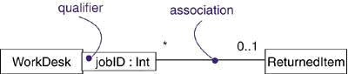

Interface Specifier
An interface is a collection of operations that are used to specify a service of a class or a component; every class may realize many interfaces. Collectively, the interfaces realized by a class represent a complete specification of the behavior of that class. However, in the context of an association with another target class, a source class may choose to present only part of its face to the world.
For example, in the vocabulary of a human resources system, a Person class may realize many interfaces: IManager, IEmployee, IOfficer, and so on. As Figure 10-6 shows, you can model the relationship between a supervisor and her workers with a one-to-many association, explicitly labeling the roles of this association as supervisor and worker. In the
context of this association, a Person in the role of supervisor presents only the IManager face to the worker; a Person in the role of worker presents only the IEmployee face to the supervisor. As the figure shows, you can explicitly show the type of role using the syntax rolename : iname, where iname is some interface of the other classifier.

Figure 10-6 Interface Specifiers

Composition

Aggregation turns out to be a simple concept with some fairly deep semantics. Simple aggregation is entirely conceptual and does nothing more than distinguish a "whole" from a "part." Simple aggregation does not change the meaning of navigation across the association between the whole and its parts, nor does it link the lifetimes of the whole and its parts.

in a composite aggregation, an object may be a part of only one composite at a time. For example, in a windowing system, a Frame belongs to exactly one Window. This is in contrast to simple aggregation, in which a part may be shared by several wholes. For example, in the model of a house, a Wall may be a part of one or more Room objects.

This means that, in a composite aggregation, an object may be a part of only one composite at a
time. For example, in a windowing system, a Frame belongs to exactly one Window. This is in
contrast to simple aggregation, in which a part may be shared by several wholes. For example, in
the model of a house, a Wall may be a part of one or more Room objects.

In addition, in a composite aggregation, the whole is responsible for the disposition of its parts,
which means that the composite must manage the creation and destruction of its parts. For example, when you create a Frame in a windowing system, you must attach it to an enclosing Window. Similarly, when you destroy the Window, the Window object must in turn destroy its Frame parts.

As Figure 10-7 shows, composition is really just a special kind of association and is specified by
adorning a plain association with a filled diamond at the whole end.

Figure 10-7 Composition

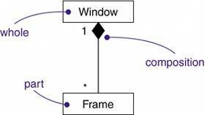

Association Classes

In an association between two classes, the association itself might have properties. For example, in an employer/employee relationship between a Company and a Person, there is a Job that represents the properties of that relationship that apply to exactly one pairing of the Person and Company. It wouldn't be appropriate to model this situation with a Company to Job association together with a Job to Person association.

In the UML, you'd model this as an association class, which is a modeling element that has both association and class properties. An association class can be seen as an association that also has class properties, or as a class that also has association properties. You render an association class as a class symbol attached by a dashed line to an association as in Figure 10-8.

Figure 10-8 Association Classes

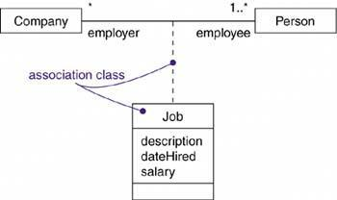

Constraints

These simple and advanced properties of associations are sufficient for most of the structural relationships you'll encounter. However, if you want to specify a shade of meaning, the UML defines five constraints that may be applied to association relationships.

First, you can specify whether the objects at one end of an association (with a multiplicity greater than one) are ordered or unordered.

First, you can distinguish if the association is real or conceptual.

1. implicit Specifies that the relationship is not manifest but, rather, is only conceptual

For example, if you have an association between two base classes, you can specify that same association between two children of those base classes (because they inherit the relationships of the parent classes). You'd mark it as implicit, because it's not manifest separately but, rather, is implicit from the relationship that exists between the parent classes. Second, you can specify that the objects at one end of an association (with a multiplicity greater than one) are ordered or unordered.

2. ordered Specifies that the set of objects at one end of an association are in an explicit order

For example, in a User/Password association, the Passwords associated with the User might
be kept in a least-recently used order, and would be marked as ordered.
.
Next, there are three properties, defined using constraint notation, that relate to the changeability
of the instances of an association.
Finally, there are three defined constraints that relate to the changeability of the instances of an
association.
3.changeable Links between objects may be added, removed, and changed freely
4. addOnly New links may be added from an object on the opposite end of the association
5. frozen A link, once added from an object on the opposite end of the association, may
not be modified or deleted

Finally, there is one constraint for managing related sets of associations:

6. xor Specifies that, over a set of associations, exactly one is manfest for each associated
object

Realizations

A realization is a semantic relationship between classifiers in which one classifier specifies a contract that another classifier guarantees to carry out. Graphically, a realization is rendered as a dashed directed line with a large open arrowhead pointing to the classifier that specifies the contract.

Realization is different enough from dependency, generalization, and association relationships that it is treated as a separate kind of relationship. Semantically, realization is somewhat of a cross between dependency and generalization, and its notation is a combination of the notation for dependency and generalization.

For example, as Figure 10-9 shows, a class (such as AccountBusinessRules in an order entry system) in a system's design view might realize a given interface (such as IRuleAgent). That same interface (IRuleAgent) might also be realized by a component (such as acctrule.dll) in the system's implementation view. Note that you can represent realization in two ways: in the canonical form (using the interface stereotype and the dashed directed line with a large open arrowhead) and in an elided form (using the interface lollipop notation).

Figure 10-9 Realization of an Interface

You'll also use realization to specify the relationship between a use case and the collaboration that realizes that use case, as Figure 10-10 shows. In this circumstance, you'll almost always use the canonical form of realization.

Figure 10-10 Realization of a Use Case

Common Modeling Techniques

Modeling Webs of Relationships

When you model the vocabulary of a complex system, you may encounter dozens, if not hundreds or thousands, of classes, interfaces, components, nodes, and use cases.

When you model these webs of relationships,

Don't begin in isolation. Apply use cases and scenarios to drive your discovery of the relationships among a set of abstractions.
In general, start by modeling the structural relationships that are present. These reflect the static view of the system and are therefore fairly tangible.
Next, identify opportunities for generalization/specialization relationships; use multiple inheritance sparingly.
Only after completing the preceding steps should you look for dependencies; they generally represent more-subtle forms of semantic connection.
For each kind of relationship, start with its basic form and apply advanced features only as absolutely necessary to express your intent.
- Remember that it is both undesirable and unnecessary to model all relationships among a set of abstractions in a single diagram or view. Rather, build up your system's relationships by considering different views on the system. Highlight interesting sets of relationships in individual diagrams.

3.Interface, Types and Roles:

The UML provides a graphical representation for interfaces, as Figure 11-1 shows. This notation
permits you to visualize the specification of an abstraction apart from any implementation.

Figure 11-1 Interfaces

Terms and Concepts

An interface is a collection of operations that are used to specify a service of a class or a component. A type is a stereotype of a class used to specify a domain of objects, together with the operations (but not the methods) applicable to the object. A role is the behavior of an entity participating in a particular context.

Graphically, an interface may be rendered as a stereotyped class in order to expose its operations and other properties.

Names

Every interface must have a name that distinguishes it from other interfaces. A name is a textual string. That name alone is known as a simple name; a path name is the interface name prefixed by the name of the package in which that interface lives. An interface may be drawn showing only its name, as in Figure 11-2:

Figure 11-2 Simple and Path Names
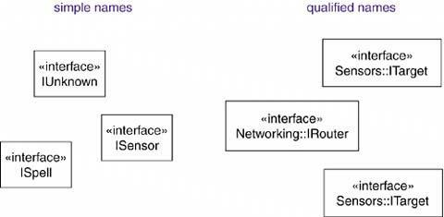

Operations

An interface is a named collection of operations used to specify a service of a class or of a component. Unlike classes or types, interfaces do not specify any implementation (so they may not include any methods, which provide the implementation of an operation). Like a class, an interface may have any number of operations. These operations may be adorned with visibility properties, concurrency properties, stereotypes, tagged values, and constraints.

When you visualize an interface in its normal form as a circle, by definition, you suppress the display of these operations. However, if it's important for your understanding of the current model, you can render an interface as a stereotyped class, listing its operations in the appropriate compartment. Operations may be drawn showing only their name, or they may be augmented to show their full signature and other properties, as in Figure 11-3.

Figure 11-3 Operations

Relationships

Like a class, an interface may participate in generalization, association, and dependency relationships. In addition, an interface may participate in realization relationships. Realization is a semantic relationship between two classifiers in which one classifier specifies a contract that another classifier guarantees to carry out.

As Figure 11-4 illustrates, you can show that an element realizes an interface in two ways. First, you can use the simple form in which the interface and its realization relationship are rendered as a lollipop sticking off to one side of a class or component. This form is useful when you simply want to expose the seams in your system. However, the limitation of this style is that you can't directly visualize the operations or signals provided by the interface. Second, you can use the expanded form in which you render an interface as a stereotyped class, which allows you to visualize its operations and other properties, and then draw a realization relationship from the classifier or component to the interface. In the UML, a realization relationship is rendered as a dashed directed line with a large open arrowhead pointing to the interface. This notation is a cross between generalization and dependency.

Figure 11-4 Realizations

Understanding an Interface

When you are handed an interface, the first thing you'll see is a set of operations that specify a service of a class or a component. Look a little deeper and you'll see the full signature of those operations, along with any of their special properties, such as visibility, scope, and concurrency semantics.

Types and Roles

A class may realize many interfaces. An instance of that class must therefore support all those interfaces, because an interface defines a contract, and any abstraction that conforms to that interface must, by definition, faithfully carry out that contract. Nonetheless, in a given context, an instance may present only one or more of its interfaces as relevant. In that case, each interface represents a role that the object plays. A role names a behavior of an entity participating in a particular context. Stated another way, a role is the face that an abstraction presents to the world.

For example, consider an instance of the class Person. Depending on the context, that Person instance may play the role of Mother, Comforter, PayerOfBills, Employee, Customer, Manager, Pilot, Singer, and so on. When an object plays a particular role, it presents a face to the world, and clients that interact with it expect a certain behavior depending on the role that it plays at the time. For example, an instance of Person in the role of Manager would present a different set of properties than if the instance were playing the role of Mother.

In the UML, you can specify a role an abstraction presents to another abstraction by adorning the
name of an association end with a specific interface. For example, Figure 11-5 shows the interface Employee, whose definition includes three operations. There exists an association between the classes Person and Company in which context Person plays the role e, whose type is Employee. In a different association, the Person might present an entirely different face to the world. With this explicit type, the role the Person plays is more than just a name meaningful to the human reader of this diagram. In the UML, this means that the Person presents the role of Employee to the Company, and in that context, only the properties specified by Employee are visible and relevant to the Company.

Figure 11-5 Roles

Common Modeling Techniques

Modeling the Seams in a System

The most common purpose for which you'll use interfaces is to model the seams in a system composed of software components, such as COM+ or Java Beans. You'll reuse some components from other systems or buy off the shelf; you will create others from scratch. In any case, you'll need to write glue code that weaves these components together. That requires you to understand the interfaces provided and relied on by each component.

Identifying the seams in a system involves identifying clear lines of demarcation in your architecture. On either side of those lines, you'll find components that may change independently, without affecting the components on the other side, as long as the components on both sides conform to the contract specified by that interface.

To model the seams in a system,

Within the collection of classes and components in your system, draw a line around those that tend to be tightly coupled relative to other sets of classes and components.
Refine your grouping by considering the impact of change. Classes or components that tend to change together should be grouped together as collaborations.
Consider the operations and the signals that cross these boundaries, from instances of one set of classes or components to instances of other sets of classes and components. Package logically related sets of these operations and signals as interfaces.
For each such collaboration in your system, identify the interfaces it requires from (imports) and those it provides to others (exports). You model the importing of interfaces by dependency relationships, and you model the exporting of interfaces by realization relationships.

For each such interface in your system, document its dynamics by using pre- and postconditions for each operation, and use cases and state machines for the interface as a whole.
For example, Figure 11-6 shows the seams surrounding a component (the library ledger.dll) drawn from a financial system. This component realizes three interfaces: IUnknown, ILedger, and IReports. In this diagram, IUnknown is shown in its expanded form; the other two are shown in their simple form, as lollipops. These three interfaces are realized by ledger.dll and are exported to other components for them to build on.

Figure 11-6 Modeling the Seams in a System

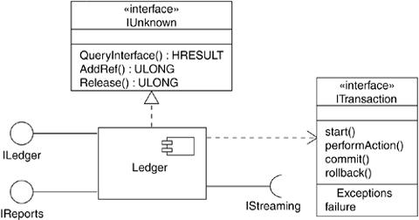

As this diagram also shows, ledger.dll imports two interfaces, IStreaming and ITransaction, the latter of which is shown in its expanded form. These two interfaces are required by the ledger.dll component for its proper operation. Therefore, in a running system, you must supply components that realize these two interfaces. By identifying interfaces such as ITransaction, you've effectively decoupled the components on either side of the interface, permitting you to employ any component that conforms to that interface.

Modeling Static and Dynamic Types

Most object-oriented programming languages are statically typed, which means that the type of an object is bound at the time the object is created. Even so, that object will likely play different roles over time. This means that clients that use that object interact with the object through different sets of interfaces, representing interesting, possibly overlapping, sets of operations.

Modeling the static nature of an object can be visualized in a class diagram. However, when you are modeling things like business objects, which naturally change their roles throughout a workflow, it's sometimes useful to explicitly model the dynamic nature of that object's type. In these circumstances, an object can gain and lose types during its life.

To model a dynamic type,

Specify the different possible types of that object by rendering each type as a class (if the abstraction requires structure and behavior) or as an interface (if the abstraction requires only behavior).
Model all the roles the class of the object may take on at any point in time. You can mark them with the «dynamic» stereotype. (This is not a predefined UML stereotype, but one that you can add.)
In an interaction diagram, properly render each instance of the dynamically typed class. Display the type of the instance in brackets below the object's name, just like a state. (We are using UML syntax in a novel way, but one that we feel is consistent with the intent of states.)
For example, Figure 11-7 shows the roles that instances of the class Person might play in the context of a human resources system.

Figure 11-7 Modeling Static Types

This diagram specifies that instances of the Person class may be any of the three types• namely, Candidate, Employee, or Retiree.
Figure 11-8 shows the dynamic nature of a person's type. In this fragment of an interaction diagram, p (the Person object) changes its role from Candidate to Employee.

Figure 11-8 Modeling Dynamic Types

4.Packages

The UML provides a graphical representation of package, as Figure 12-1 shows. This notation
permits you to visualize groups of elements that can be manipulated as a whole and in a way that
lets you control the visibility of and access to individual elements.

Figure 12-1 Packages
Terms and Concepts

A package is a general-purpose mechanism for organizing the model itself into a hierarchy; it has no meaning to the execution. Graphically, a package is rendered as a tabbed folder. The name of the package goes in the folder (if its contents are not shown) or in the tab (if the contents of the folder are shown).

Names

Every package must have a name that distinguishes it from other packages. A name is a textual string. That name alone is known as a simple name; a qualified name is the package name prefixed by the name of the package in which that package lives, if any. A double colon (::) separates package names. A package is typically drawn showing only its name, as in Figure 12-2. Just as with classes, you may draw packages adorned with tagged values or with additional compartments to expose their details.

Figure 12-2 Simple and Extended Package

Owned Elements

A package may own other elements, including classes, interfaces, components, nodes, collaborations, use cases, diagrams, and even other packages. Ownership is a composite relationship, which means that the element is declared in the package. If the package is destroyed, the element is destroyed. Every element is uniquely owned by exactly one package.

As Figure 12-3 shows, you can explicitly show the contents of a package either textually or graphically. Note that when you show these owned elements, you place the name of the package in the tab. In practice, you typically won't want to show the contents of packages this way. Instead, you'll use tools to zoom into the contents of a package.

Figure 12-3 Owned Elements

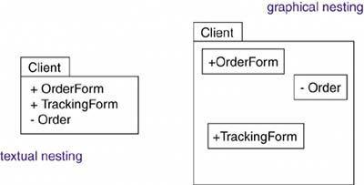

Visibility

You can control the visibility of the elements owned by a package just as you can control the visibility of the attributes and operations owned by a class. Typically, an element owned by a package is public, which means that it is visible to the contents of any package that imports the element's enclosing package. Conversely, protected elements can only be seen by children, and private elements cannot be seen outside the package in which they are declared.

In Figure 12-3, OrderForm is a public part of the package Client, and Order is a private part. A package that imports Client can see OrderForm, but it cannot see Order. As viewed from the outside, the fully qualified name of OrderForm would be Client::OrderForm. You specify the visibility of an element owned by a package by prefixing the element's name with an appropriate visibility symbol. Public elements are rendered by prefixing their name with a + symbol, as for OrderForm in Figure 12-3. Collectively, the public parts of a package constitute the package's interface.

Importing and Exporting

suppose that instead you put A in one package and B in another package, both packages sitting side by side. Suppose also that A and B are both declared as public parts of their respective packages. This is a very different situation. Although A and B are both public, accessing one of the classes from within the other package requires a qualified name. However, if A's package imports B's package, A can now see B directly, although still B cannot see A without a qualified name. Importing adds the public elements from the target package to the public namespace of the importing package. In the UML, you model an import relationship as a dependency adorned with the stereotype import. By packaging your abstractions into meaningful chunks and then controlling their access by importing, you can control the complexity of large numbers of abstractions.

The public parts of a package are called its exports. For example, in Figure 12-4, the package GUI exports two classes, Window and Form. EventHandler is not exported by GUI; EventHandler is a protected part of the package.

Figure 12-4 Importing and Exporting

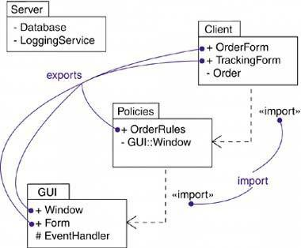

The parts that one package exports are visible only to the contents of those packages that explicitly import the package. In this example, Policies explicitly imports the package GUI. GUI::Window and GUI::Form are therefore made visible to the contents of the package Policies. However, GUI::EventHandler is not visible because it is protected. Because the package Server doesn't import GUI, the contents of Server don't have permission to access any of the contents of GUI. Similarly, the contents of GUI don't have permission to access any of the contents of Server.

Import and access dependencies are not transitive. In this example, Client imports Policies and Policies imports GUI, but Client does not by implication import GUI. Therefore, the contents of Client have access to the exports of Policies, but they do not have access to the exports of GUI. To gain access, Client would have to import GUI explicitly.
Generalization

There are two kinds of relationships you can have between packages: import and access dependencies, used to import into one package elements exported from another, and generalizations, used to specify families of packages. Generalization among packages is very much like generalization among classes.

For example, in Figure 12-5, the package GUI is shown to export two classes (Window and Form) and one protected class (EventHandler). Two packages specialize the more general package GUI: WindowsGUI and MacGUI. These specialized packages inherit the public and protected elements of the more general package. But, just as in class inheritance, packages can replace more general elements and add new ones. For example, the package WindowsGUI inherits from GUI, so it includes the classes GUI::Window and GUI::EventHandler. In addition,
WindowsGUI overrides one class (Form) and adds a new one (VBForm).

Figure 12-5 Generalization Among Packages

Standard Elements

All of the UML's extensibility mechanisms apply to packages. Most often, you'll use tagged values to add new package properties (such as specifying the author of a package) and stereotypes to specify new kinds of packages (such as packages that encapsulate operating system services).

The UML defines five standard stereotypes that apply to packages.

Common Modeling Techniques

Modeling Groups of Elements

There is one important distinction between classes and packages: Classes are abstractions of things found in your problem or solution; packages are mechanisms you use to organize the things in your model. Packages have no identity (meaning that you can't have instances of packages, so they are invisible in the running system); classes do have identity (classes have instances, which are elements of a running system).

You can also use packages to group different kinds of elements. For example, for a system being developed by a geographically distributed team, you might use packages as your unit of configuration management, putting in them all the classes and diagrams that each team can check in and check out separately. In fact, it's common to use packages to group modeling elements and their associated diagrams.

To model groups of elements,

Scan the modeling elements in a particular architectural view and look for clumps defined by elements that are conceptually or semantically close to one another.
Surround each of these clumps in a package.
For each package, distinguish which elements should be accessible outside the package. Mark them public, and all others protected or private. When in doubt, hide the element. Explicitly connect packages that build on others via import dependencies.
In the case of families of packages, connect specialized packages to their more general part via generalizations.

For example, Figure 12-6 shows a set of packages that organize the classes in an information system's design view into a classic three-tier architecture. The elements in the package User Services provide the visual interface for presenting information and gathering data. The elements in the package Data Services maintain, access, and update data. The elements in the package Business Services bridge the elements in the other two packages and encompass all the classes and other elements that manage requests from the user to execute a business task, including business rules that dictate the policies for manipulating data.

Figure 12-6 Modeling Groups of Elements

Modeling Architectural Views

Using packages to group related elements is important; you can't develop complex models without doing so. This approach works well for organizing related elements, such as classes, interfaces, components, nodes, and diagrams. As you consider the different views of a software system's architecture, you need even larger chunks. You can use packages to model the views of an architecture.

To model architectural views,

· Identify the set of architectural views that are significant in the context of your problem. In
practice, this typically includes a design view, a process view, an implementation view, a
deployment view, and a use case view.

· Place the elements (and diagrams) that are necessary and sufficient to visualize, specify,
construct, and document the semantics of each view into the appropriate package.

· As necessary, further group these elements into their own packages.

· There will typically be dependencies across the elements in different views. So, in
general, let each view at the top of a system be open to all others at that level.

For example, Figure 12-7 illustrates a canonical top-level decomposition that's appropriate for
even the most complex system you might encounter.

Figure 12-7 Modeling Architectural Views

